Added A2 images and removed bad images: .35 (epoch 74) 1000

true positives = 100  
true negatives = 532  
false positives = 39  
false negatives = 26  
not confident of any answer = 35  
total = 732  
  
sensitivity = 0.7937  
specificity = 0.9317  
precision = 0.7194  
recall = 0.7937

 normal#255 **Confidences:**normal = 1%; non-serious = 99%; warrants second opinion = 0%;   
The nail's condition is non-serious with confidence score of 99%.  
Otherwise it is normal with confidence score of 1%.×

 normal#850 **Confidences:**normal = 1%; non-serious = 99%; warrants second opinion = 0%;   
The nail's condition is non-serious with confidence score of 99%.  
Otherwise it is normal with confidence score of 1%.×

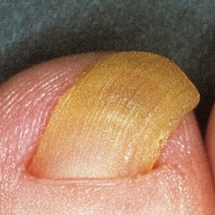 normal#1005 **Confidences:**normal = 1%; non-serious = 99%; warrants second opinion = 0%;   
The nail's condition is non-serious with confidence score of 99%.  
Otherwise it is normal with confidence score of 1%.×

 normal#70 **Confidences:**normal = 2%; non-serious = 11%; warrants second opinion = 87%;   
It is most likely that the nail indicates something that warrants a second opinion and you should seek medical advice. (Confidence score is 87%)×

 normal#650 **Confidences:**normal = 2%; non-serious = 94%; warrants second opinion = 4%;   
The nail's condition is non-serious with confidence score of 94%.  
The confidence score for it warranting a second opinion is 4%.×

 normal#310 **Confidences:**normal = 3%; non-serious = 11%; warrants second opinion = 86%;   
It is most likely that the nail indicates something that warrants a second opinion and you should seek medical advice. (Confidence score is 86%)×

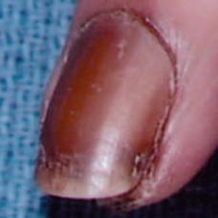 normal#1125 **Confidences:**normal = 4%; non-serious = 13%; warrants second opinion = 83%;   
It is most likely that the nail indicates something that warrants a second opinion and you should seek medical advice. (Confidence score is 83%)×

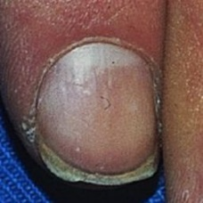 normal#1045 **Confidences:**normal = 6%; non-serious = 93%; warrants second opinion = 0%;   
The nail's condition is non-serious with confidence score of 93%.  
Otherwise it is normal with confidence score of 6%.×

 normal#415 **Confidences:**normal = 9%; non-serious = 90%; warrants second opinion = 0%;   
The nail's condition is non-serious with confidence score of 90%.  
Otherwise it is normal with confidence score of 9%.×

 normal#345 **Confidences:**normal = 13%; non-serious = 0%; warrants second opinion = 87%;   
It is most likely that the nail indicates something that warrants a second opinion and you should seek medical advice. (Confidence score is 87%)×

 normal#430 **Confidences:**normal = 13%; non-serious = 86%; warrants second opinion = 0%;   
The nail's condition is non-serious with confidence score of 86%.  
Otherwise it is normal with confidence score of 13%.×

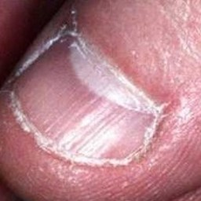 normal#1260 **Confidences:**normal = 17%; non-serious = 83%; warrants second opinion = 0%;   
The nail's condition is non-serious with confidence score of 83%.  
Otherwise it is normal with confidence score of 17%.×

 normal#925 **Confidences:**normal = 17%; non-serious = 0%; warrants second opinion = 83%;   
It is most likely that the nail indicates something that warrants a second opinion and you should seek medical advice. (Confidence score is 83%)×

 normal#185 **Confidences:**normal = 18%; non-serious = 82%; warrants second opinion = 0%;   
The nail's condition is non-serious with confidence score of 82%.  
Otherwise it is normal with confidence score of 18%.×

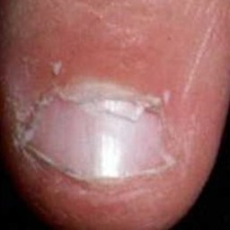 normal#1270 **Confidences:**normal = 19%; non-serious = 81%; warrants second opinion = 0%;   
The nail's condition is non-serious with confidence score of 81%.  
Otherwise it is normal with confidence score of 19%.×

 normal#230 **Confidences:**normal = 20%; non-serious = 80%; warrants second opinion = 0%;   
The nail's condition is non-serious with confidence score of 80%.  
Otherwise it is normal with confidence score of 20%.×

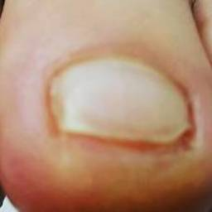 normal#1345 **Confidences:**normal = 23%; non-serious = 26%; warrants second opinion = 51%;   
Not very sure whether the nail is OK or not. Sorry.×

 normal#145 **Confidences:**normal = 24%; non-serious = 34%; warrants second opinion = 41%;   
Not very sure whether the nail is OK or not. Sorry.×

 normal#1060 **Confidences:**normal = 26%; non-serious = 29%; warrants second opinion = 45%;   
Not very sure whether the nail is OK or not. Sorry.×

 normal#325 **Confidences:**normal = 29%; non-serious = 69%; warrants second opinion = 2%;   
The nail's condition is non-serious with confidence score of 69%.  
Otherwise it is normal with confidence score of 29%.×

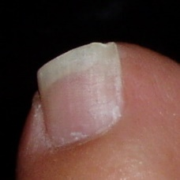 normal#1305 **Confidences:**normal = 32%; non-serious = 68%; warrants second opinion = 0%;   
The nail's condition is non-serious with confidence score of 68%.  
Otherwise it is normal with confidence score of 32%.×

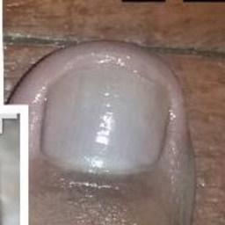 normal#1080 **Confidences:**normal = 36%; non-serious = 52%; warrants second opinion = 12%;   
Not very sure whether the nail is OK or not. Sorry.×

 normal#95 **Confidences:**normal = 36%; non-serious = 54%; warrants second opinion = 10%;   
Not very sure whether the nail is OK or not. Sorry.×

 normal#835 **Confidences:**normal = 36%; non-serious = 3%; warrants second opinion = 61%;   
It is most likely that the nail indicates something that warrants a second opinion and you should seek medical advice. (Confidence score is 61%)×

 normal#175 **Confidences:**normal = 37%; non-serious = 2%; warrants second opinion = 61%;   
It is most likely that the nail indicates something that warrants a second opinion and you should seek medical advice. (Confidence score is 61%)×

 normal#745 **Confidences:**normal = 38%; non-serious = 51%; warrants second opinion = 11%;   
Not very sure whether the nail is OK or not. Sorry.×

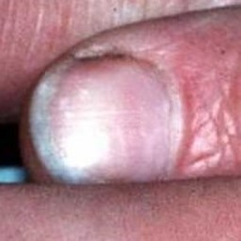 normal#1220 **Confidences:**normal = 44%; non-serious = 53%; warrants second opinion = 3%;   
Not very sure whether the nail is OK or not. Sorry.×

 normal#440 **Confidences:**normal = 46%; non-serious = 53%; warrants second opinion = 2%;   
Not very sure whether the nail is OK or not. Sorry.×

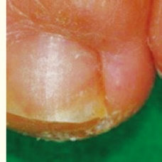 normal#1315 **Confidences:**normal = 47%; non-serious = 52%; warrants second opinion = 1%;   
Not very sure whether the nail is OK or not. Sorry.×

 normal#530 **Confidences:**normal = 49%; non-serious = 0%; warrants second opinion = 50%;   
Not very sure whether the nail is OK or not. Sorry.×

 normal#470 **Confidences:**normal = 50%; non-serious = 4%; warrants second opinion = 47%;   
Not very sure whether the nail is OK or not. Sorry.×

 normal#875 **Confidences:**normal = 50%; non-serious = 49%; warrants second opinion = 2%;   
Not very sure whether the nail is OK or not. Sorry.×

 normal#555 **Confidences:**normal = 50%; non-serious = 50%; warrants second opinion = 0%;   
Not very sure whether the nail is OK or not. Sorry.×

 normal#20 **Confidences:**normal = 50%; non-serious = 48%; warrants second opinion = 2%;   
Not very sure whether the nail is OK or not. Sorry.×

 normal#225 **Confidences:**normal = 51%; non-serious = 0%; warrants second opinion = 49%;   
Not very sure whether the nail is OK or not. Sorry.×

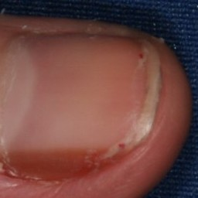 normal#1115 **Confidences:**normal = 52%; non-serious = 0%; warrants second opinion = 48%;   
Not very sure whether the nail is OK or not. Sorry.×

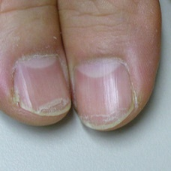 normal#1110 **Confidences:**normal = 57%; non-serious = 6%; warrants second opinion = 37%;   
Not very sure whether the nail is OK or not. Sorry.×

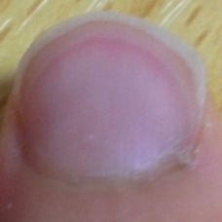 normal#1320 **Confidences:**normal = 58%; non-serious = 42%; warrants second opinion = 0%;   
Not very sure whether the nail is OK or not. Sorry.×

 normal#100 **Confidences:**normal = 58%; non-serious = 0%; warrants second opinion = 42%;   
Not very sure whether the nail is OK or not. Sorry.×

 normal#665 **Confidences:**normal = 60%; non-serious = 2%; warrants second opinion = 38%;   
It might be warrant a second opinion (confidence score is 38%) ×

 normal#105 **Confidences:**normal = 61%; non-serious = 8%; warrants second opinion = 31%;   
It might be warrant a second opinion (confidence score is 31%) ×

 normal#265 **Confidences:**normal = 61%; non-serious = 3%; warrants second opinion = 36%;   
It might be warrant a second opinion (confidence score is 36%) ×

 normal#620 **Confidences:**normal = 61%; non-serious = 0%; warrants second opinion = 39%;   
It might be warrant a second opinion (confidence score is 39%) ×

 normal#485 **Confidences:**normal = 63%; non-serious = 37%; warrants second opinion = 0%;   
The nail's condition is normal with confidence score of 63%.  
Otherwise it is non-serious with confidence score of 37%.×

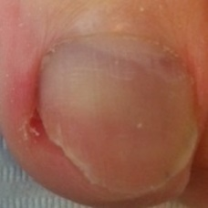 normal#1190 **Confidences:**normal = 63%; non-serious = 19%; warrants second opinion = 18%;   
The nail's condition is normal with confidence score of 63%.  
Otherwise it is non-serious with confidence score of 19%.×

 normal#900 **Confidences:**normal = 65%; non-serious = 23%; warrants second opinion = 12%;   
The nail's condition is normal with confidence score of 65%.  
Otherwise it is non-serious with confidence score of 23%.×

 normal#190 **Confidences:**normal = 65%; non-serious = 13%; warrants second opinion = 22%;   
It might be warrant a second opinion (confidence score is 22%) ×

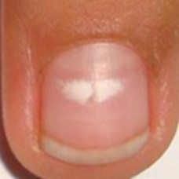 normal#1275 **Confidences:**normal = 66%; non-serious = 4%; warrants second opinion = 31%;   
It might be warrant a second opinion (confidence score is 31%) ×

 normal#350 **Confidences:**normal = 68%; non-serious = 2%; warrants second opinion = 30%;   
It might be warrant a second opinion (confidence score is 30%) ×

 normal#10 **Confidences:**normal = 69%; non-serious = 31%; warrants second opinion = 0%;   
The nail's condition is normal with confidence score of 69%.  
Otherwise it is non-serious with confidence score of 31%.×

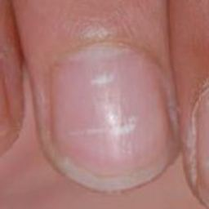 normal#1215 **Confidences:**normal = 70%; non-serious = 0%; warrants second opinion = 30%;   
It might be warrant a second opinion (confidence score is 30%) ×

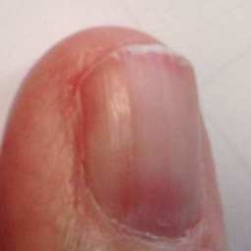 normal#1140 **Confidences:**normal = 71%; non-serious = 19%; warrants second opinion = 11%;   
The nail's condition is normal with confidence score of 71%.  
Otherwise it is non-serious with confidence score of 19%.×

 normal#30 **Confidences:**normal = 72%; non-serious = 7%; warrants second opinion = 21%;   
It might be warrant a second opinion (confidence score is 21%) ×

 normal#660 **Confidences:**normal = 73%; non-serious = 1%; warrants second opinion = 26%;   
It might be warrant a second opinion (confidence score is 26%) ×

 normal#340 **Confidences:**normal = 76%; non-serious = 18%; warrants second opinion = 7%;   
The nail's condition is normal with confidence score of 76%.  
Otherwise it is non-serious with confidence score of 18%.×

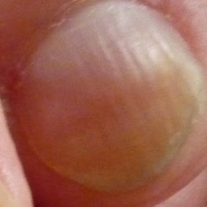 normal#1070 **Confidences:**normal = 77%; non-serious = 18%; warrants second opinion = 5%;   
The nail's condition is normal with confidence score of 77%.  
Otherwise it is non-serious with confidence score of 18%.×

 normal#645 **Confidences:**normal = 80%; non-serious = 0%; warrants second opinion = 20%;   
It might be warrant a second opinion (confidence score is 20%) ×

 normal#885 **Confidences:**normal = 81%; non-serious = 0%; warrants second opinion = 19%;   
The nail's condition is normal with confidence score of 81%.  
The confidence score for it warranting a second opinion is 19%.×

 normal#680 **Confidences:**normal = 81%; non-serious = 17%; warrants second opinion = 3%;   
The nail's condition is normal with confidence score of 81%.  
Otherwise it is non-serious with confidence score of 17%.×

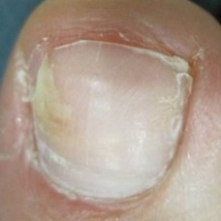 normal#1165 **Confidences:**normal = 81%; non-serious = 0%; warrants second opinion = 19%;   
The nail's condition is normal with confidence score of 81%.  
The confidence score for it warranting a second opinion is 19%.×

 normal#670 **Confidences:**normal = 82%; non-serious = 17%; warrants second opinion = 1%;   
The nail's condition is normal with confidence score of 82%.  
Otherwise it is non-serious with confidence score of 17%.×

 normal#205 **Confidences:**normal = 82%; non-serious = 16%; warrants second opinion = 2%;   
The nail's condition is normal with confidence score of 82%.  
Otherwise it is non-serious with confidence score of 16%.×

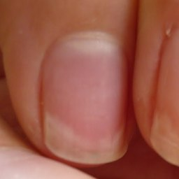 normal#1335 **Confidences:**normal = 82%; non-serious = 0%; warrants second opinion = 18%;   
The nail's condition is normal with confidence score of 82%.  
The confidence score for it warranting a second opinion is 18%.×

 normal#135 **Confidences:**normal = 83%; non-serious = 16%; warrants second opinion = 0%;   
The nail's condition is normal with confidence score of 83%.  
Otherwise it is non-serious with confidence score of 16%.×

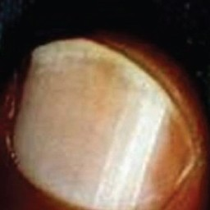 normal#1230 **Confidences:**normal = 84%; non-serious = 15%; warrants second opinion = 0%;   
The nail's condition is normal with confidence score of 84%.  
Otherwise it is non-serious with confidence score of 15%.×

 normal#600 **Confidences:**normal = 85%; non-serious = 0%; warrants second opinion = 15%;   
The nail's condition is normal with confidence score of 85%.  
The confidence score for it warranting a second opinion is 15%.×

 normal#605 **Confidences:**normal = 85%; non-serious = 2%; warrants second opinion = 13%;   
The nail's condition is normal with confidence score of 85%.  
The confidence score for it warranting a second opinion is 13%.×

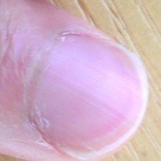 normal#1280 **Confidences:**normal = 85%; non-serious = 1%; warrants second opinion = 14%;   
The nail's condition is normal with confidence score of 85%.  
The confidence score for it warranting a second opinion is 14%.×

 normal#260 **Confidences:**normal = 86%; non-serious = 0%; warrants second opinion = 13%;   
The nail's condition is normal with confidence score of 86%.  
The confidence score for it warranting a second opinion is 13%.×

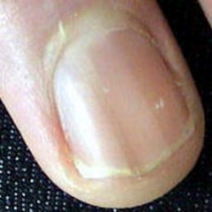 normal#1135 **Confidences:**normal = 87%; non-serious = 2%; warrants second opinion = 11%;   
The nail's condition is normal with confidence score of 87%.  
The confidence score for it warranting a second opinion is 11%.×

 normal#890 **Confidences:**normal = 87%; non-serious = 0%; warrants second opinion = 13%;   
The nail's condition is normal with confidence score of 87%.  
The confidence score for it warranting a second opinion is 13%.×

 normal#275 **Confidences:**normal = 87%; non-serious = 12%; warrants second opinion = 1%;   
The nail's condition is normal with confidence score of 87%.  
Otherwise it is non-serious with confidence score of 12%.×

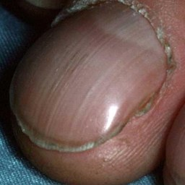 normal#1160 **Confidences:**normal = 88%; non-serious = 3%; warrants second opinion = 10%;   
The nail's condition is normal with confidence score of 88%.  
The confidence score for it warranting a second opinion is 10%.×

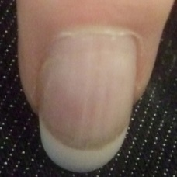 normal#1120 **Confidences:**normal = 88%; non-serious = 12%; warrants second opinion = 0%;   
The nail's condition is normal with confidence score of 88%.  
Otherwise it is non-serious with confidence score of 12%.×

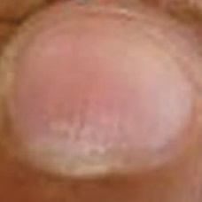 normal#1240 **Confidences:**normal = 88%; non-serious = 12%; warrants second opinion = 0%;   
The nail's condition is normal with confidence score of 88%.  
Otherwise it is non-serious with confidence score of 12%.×

 normal#565 **Confidences:**normal = 89%; non-serious = 0%; warrants second opinion = 11%;   
The nail's condition is normal with confidence score of 89%.  
The confidence score for it warranting a second opinion is 11%.×

 normal#180 **Confidences:**normal = 89%; non-serious = 2%; warrants second opinion = 10%;   
The nail's condition is normal with confidence score of 89%.  
The confidence score for it warranting a second opinion is 10%.×

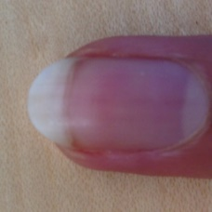 normal#1130 **Confidences:**normal = 90%; non-serious = 0%; warrants second opinion = 10%;   
The nail's condition is normal with confidence score of 90%.  
The confidence score for it warranting a second opinion is 10%.×

 normal#955 **Confidences:**normal = 90%; non-serious = 10%; warrants second opinion = 0%;   
The nail's condition is normal with confidence score of 90%.  
Otherwise it is non-serious with confidence score of 10%.×

 normal#775 **Confidences:**normal = 90%; non-serious = 1%; warrants second opinion = 9%;   
The nail's condition is normal with confidence score of 90%.  
The confidence score for it warranting a second opinion is 9%.×

 normal#290 **Confidences:**normal = 91%; non-serious = 5%; warrants second opinion = 4%;   
The nail's condition is normal with confidence score of 91%.  
Otherwise it is non-serious with confidence score of 5%.×

 normal#825 **Confidences:**normal = 91%; non-serious = 9%; warrants second opinion = 0%;   
The nail's condition is normal with confidence score of 91%.  
Otherwise it is non-serious with confidence score of 9%.×

 normal#125 **Confidences:**normal = 91%; non-serious = 3%; warrants second opinion = 6%;   
The nail's condition is normal with confidence score of 91%.  
The confidence score for it warranting a second opinion is 6%.×

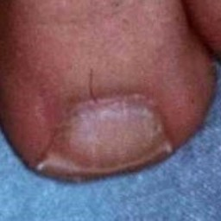 normal#1075 **Confidences:**normal = 91%; non-serious = 9%; warrants second opinion = 0%;   
The nail's condition is normal with confidence score of 91%.  
Otherwise it is non-serious with confidence score of 9%.×

 normal#785 **Confidences:**normal = 91%; non-serious = 5%; warrants second opinion = 3%;   
The nail's condition is normal with confidence score of 91%.  
Otherwise it is non-serious with confidence score of 5%.×

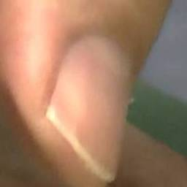 normal#1290 **Confidences:**normal = 92%; non-serious = 8%; warrants second opinion = 1%;   
The nail's condition is normal with confidence score of 92%.  
Otherwise it is non-serious with confidence score of 8%.×

 normal#735 **Confidences:**normal = 92%; non-serious = 7%; warrants second opinion = 1%;   
The nail's condition is normal with confidence score of 92%.  
Otherwise it is non-serious with confidence score of 7%.×

 normal#220 **Confidences:**normal = 92%; non-serious = 0%; warrants second opinion = 8%;   
The nail's condition is normal with confidence score of 92%.  
The confidence score for it warranting a second opinion is 8%.×

 normal#15 **Confidences:**normal = 93%; non-serious = 0%; warrants second opinion = 7%;   
The nail's condition is normal with confidence score of 93%.  
The confidence score for it warranting a second opinion is 7%.×

 normal#315 **Confidences:**normal = 93%; non-serious = 0%; warrants second opinion = 7%;   
The nail's condition is normal with confidence score of 93%.  
The confidence score for it warranting a second opinion is 7%.×

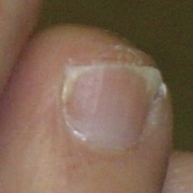 normal#1030 **Confidences:**normal = 93%; non-serious = 7%; warrants second opinion = 0%;   
The nail's condition is normal with confidence score of 93%.  
Otherwise it is non-serious with confidence score of 7%.×

 normal#1085 **Confidences:**normal = 93%; non-serious = 7%; warrants second opinion = 0%;   
The nail's condition is normal with confidence score of 93%.  
Otherwise it is non-serious with confidence score of 7%.×

 normal#40 **Confidences:**normal = 93%; non-serious = 0%; warrants second opinion = 7%;   
The nail's condition is normal with confidence score of 93%.  
The confidence score for it warranting a second opinion is 7%.×

 normal#150 **Confidences:**normal = 93%; non-serious = 7%; warrants second opinion = 0%;   
The nail's condition is normal with confidence score of 93%.  
Otherwise it is non-serious with confidence score of 7%.×

 normal#475 **Confidences:**normal = 93%; non-serious = 3%; warrants second opinion = 4%;   
The nail's condition is normal with confidence score of 93%.  
The confidence score for it warranting a second opinion is 4%.×

 normal#280 **Confidences:**normal = 94%; non-serious = 0%; warrants second opinion = 6%;   
The nail's condition is normal with confidence score of 94%.  
The confidence score for it warranting a second opinion is 6%.×

 normal#160 **Confidences:**normal = 94%; non-serious = 6%; warrants second opinion = 0%;   
The nail's condition is normal with confidence score of 94%.  
Otherwise it is non-serious with confidence score of 6%.×

 normal#380 **Confidences:**normal = 94%; non-serious = 5%; warrants second opinion = 1%;   
The nail's condition is normal with confidence score of 94%.  
Otherwise it is non-serious with confidence score of 5%.×

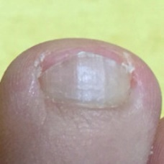 normal#1340 **Confidences:**normal = 95%; non-serious = 5%; warrants second opinion = 0%;   
The nail's condition is normal with confidence score of 95%.  
Otherwise it is non-serious with confidence score of 5%.×

 normal#1065 **Confidences:**normal = 95%; non-serious = 0%; warrants second opinion = 5%;   
The nail's condition is normal with confidence score of 95%.  
The confidence score for it warranting a second opinion is 5%.×

 normal#450 **Confidences:**normal = 95%; non-serious = 0%; warrants second opinion = 5%;   
The nail's condition is normal with confidence score of 95%.  
The confidence score for it warranting a second opinion is 5%.×

 normal#710 **Confidences:**normal = 95%; non-serious = 4%; warrants second opinion = 1%;   
The nail's condition is normal with confidence score of 95%.  
Otherwise it is non-serious with confidence score of 4%.×

 normal#250 **Confidences:**normal = 96%; non-serious = 4%; warrants second opinion = 0%;   
The nail's condition is normal with confidence score of 96%.  
Otherwise it is non-serious with confidence score of 4%.×

 normal#810 **Confidences:**normal = 96%; non-serious = 0%; warrants second opinion = 4%;   
The nail's condition is normal with confidence score of 96%.  
The confidence score for it warranting a second opinion is 4%.×

 normal#200 **Confidences:**normal = 96%; non-serious = 1%; warrants second opinion = 3%;   
The nail's condition is normal with confidence score of 96%.  
The confidence score for it warranting a second opinion is 3%.×

 normal#790 **Confidences:**normal = 96%; non-serious = 3%; warrants second opinion = 1%;   
The nail's condition is normal with confidence score of 96%.  
Otherwise it is non-serious with confidence score of 3%.×

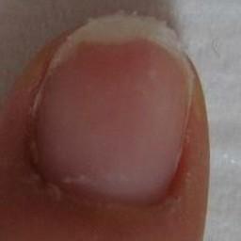 normal#1055 **Confidences:**normal = 96%; non-serious = 1%; warrants second opinion = 3%;   
The nail's condition is normal with confidence score of 96%.  
The confidence score for it warranting a second opinion is 3%.×

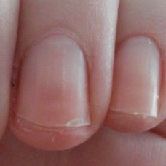 normal#1200 **Confidences:**normal = 96%; non-serious = 0%; warrants second opinion = 4%;   
The nail's condition is normal with confidence score of 96%.  
The confidence score for it warranting a second opinion is 4%.×

 normal#410 **Confidences:**normal = 96%; non-serious = 0%; warrants second opinion = 4%;   
The nail's condition is normal with confidence score of 96%.  
The confidence score for it warranting a second opinion is 4%.×

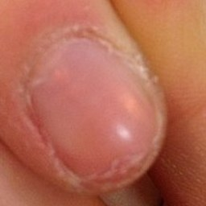 normal#1350 **Confidences:**normal = 96%; non-serious = 4%; warrants second opinion = 0%;   
The nail's condition is normal with confidence score of 96%.  
Otherwise it is non-serious with confidence score of 4%.×

 normal#5 **Confidences:**normal = 96%; non-serious = 2%; warrants second opinion = 1%;   
The nail's condition is normal with confidence score of 96%.  
Otherwise it is non-serious with confidence score of 2%.×

 normal#90 **Confidences:**normal = 96%; non-serious = 3%; warrants second opinion = 1%;   
The nail's condition is normal with confidence score of 96%.  
Otherwise it is non-serious with confidence score of 3%.×

 normal#940 **Confidences:**normal = 96%; non-serious = 1%; warrants second opinion = 3%;   
The nail's condition is normal with confidence score of 96%.  
The confidence score for it warranting a second opinion is 3%.×

 normal#805 **Confidences:**normal = 97%; non-serious = 0%; warrants second opinion = 3%;   
The nail's condition is normal with confidence score of 97%.  
The confidence score for it warranting a second opinion is 3%.×

 normal#550 **Confidences:**normal = 97%; non-serious = 3%; warrants second opinion = 0%;   
The nail's condition is normal with confidence score of 97%.  
Otherwise it is non-serious with confidence score of 3%.×

 normal#460 **Confidences:**normal = 97%; non-serious = 2%; warrants second opinion = 1%;   
The nail's condition is normal with confidence score of 97%.  
Otherwise it is non-serious with confidence score of 2%.×

 normal#860 **Confidences:**normal = 97%; non-serious = 0%; warrants second opinion = 3%;   
The nail's condition is normal with confidence score of 97%.  
The confidence score for it warranting a second opinion is 3%.×

 normal#635 **Confidences:**normal = 97%; non-serious = 0%; warrants second opinion = 3%;   
The nail's condition is normal with confidence score of 97%.  
The confidence score for it warranting a second opinion is 3%.×

 normal#335 **Confidences:**normal = 97%; non-serious = 0%; warrants second opinion = 3%;   
The nail's condition is normal with confidence score of 97%.  
The confidence score for it warranting a second opinion is 3%.×

 normal#865 **Confidences:**normal = 97%; non-serious = 0%; warrants second opinion = 3%;   
The nail's condition is normal with confidence score of 97%.  
The confidence score for it warranting a second opinion is 3%.×

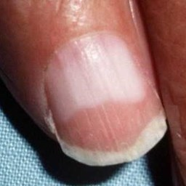 normal#1185 **Confidences:**normal = 97%; non-serious = 3%; warrants second opinion = 0%;   
The nail's condition is normal with confidence score of 97%.  
Otherwise it is non-serious with confidence score of 3%.×

 normal#740 **Confidences:**normal = 97%; non-serious = 1%; warrants second opinion = 2%;   
The nail's condition is normal with confidence score of 97%.  
The confidence score for it warranting a second opinion is 2%.×

 normal#880 **Confidences:**normal = 97%; non-serious = 2%; warrants second opinion = 0%;   
The nail's condition is normal with confidence score of 97%.  
Otherwise it is non-serious with confidence score of 2%.×

 normal#945 **Confidences:**normal = 97%; non-serious = 2%; warrants second opinion = 0%;   
The nail's condition is normal with confidence score of 97%.  
Otherwise it is non-serious with confidence score of 2%.×

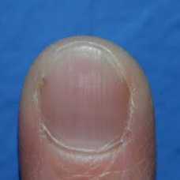 normal#1105 **Confidences:**normal = 97%; non-serious = 0%; warrants second opinion = 2%;   
The nail's condition is normal with confidence score of 97%.  
The confidence score for it warranting a second opinion is 2%.×

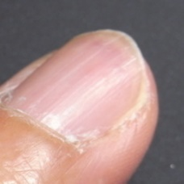 normal#1310 **Confidences:**normal = 97%; non-serious = 2%; warrants second opinion = 1%;   
The nail's condition is normal with confidence score of 97%.  
Otherwise it is non-serious with confidence score of 2%.×

 normal#505 **Confidences:**normal = 98%; non-serious = 1%; warrants second opinion = 2%;   
The nail's condition is normal with confidence score of 98%.  
The confidence score for it warranting a second opinion is 2%.×

 normal#730 **Confidences:**normal = 98%; non-serious = 1%; warrants second opinion = 2%;   
The nail's condition is normal with confidence score of 98%.  
The confidence score for it warranting a second opinion is 2%.×

 normal#295 **Confidences:**normal = 98%; non-serious = 0%; warrants second opinion = 2%;   
The nail's condition is normal with confidence score of 98%.  
The confidence score for it warranting a second opinion is 2%.×

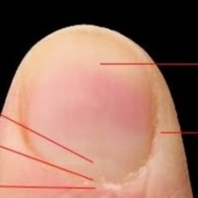 normal#1100 **Confidences:**normal = 98%; non-serious = 2%; warrants second opinion = 0%;   
The nail's condition is normal with confidence score of 98%.  
Otherwise it is non-serious with confidence score of 2%.×

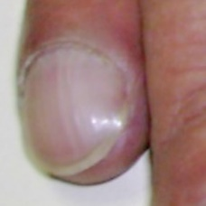 normal#1095 **Confidences:**normal = 98%; non-serious = 1%; warrants second opinion = 1%;   
The nail's condition is normal with confidence score of 98%.  
Otherwise it is non-serious with confidence score of 1%.×

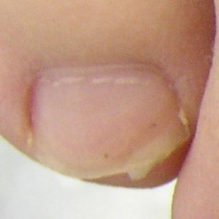 normal#1225 **Confidences:**normal = 98%; non-serious = 2%; warrants second opinion = 1%;   
The nail's condition is normal with confidence score of 98%.  
Otherwise it is non-serious with confidence score of 2%.×

 normal#540 **Confidences:**normal = 98%; non-serious = 2%; warrants second opinion = 0%;   
The nail's condition is normal with confidence score of 98%.  
Otherwise it is non-serious with confidence score of 2%.×

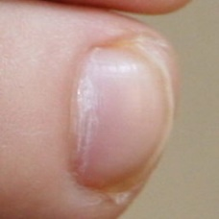 normal#1020 **Confidences:**normal = 98%; non-serious = 0%; warrants second opinion = 2%;   
The nail's condition is normal with confidence score of 98%.  
The confidence score for it warranting a second opinion is 2%.×

 normal#985 **Confidences:**normal = 98%; non-serious = 2%; warrants second opinion = 0%;   
The nail's condition is normal with confidence score of 98%.  
Otherwise it is non-serious with confidence score of 2%.×

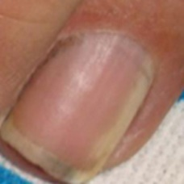 normal#1245 **Confidences:**normal = 98%; non-serious = 1%; warrants second opinion = 1%;   
The nail's condition is normal with confidence score of 98%.  
Otherwise it is non-serious with confidence score of 1%.×

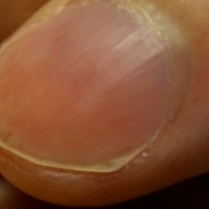 normal#1285 **Confidences:**normal = 98%; non-serious = 1%; warrants second opinion = 0%;   
The nail's condition is normal with confidence score of 98%.  
Otherwise it is non-serious with confidence score of 1%.×

 normal#35 **Confidences:**normal = 98%; non-serious = 1%; warrants second opinion = 1%;   
The nail's condition is normal with confidence score of 98%.  
Otherwise it is non-serious with confidence score of 1%.×

 normal#285 **Confidences:**normal = 98%; non-serious = 0%; warrants second opinion = 2%;   
The nail's condition is normal with confidence score of 98%.  
The confidence score for it warranting a second opinion is 2%.×

 normal#845 **Confidences:**normal = 98%; non-serious = 2%; warrants second opinion = 0%;   
The nail's condition is normal with confidence score of 98%.  
Otherwise it is non-serious with confidence score of 2%.×

 normal#405 **Confidences:**normal = 98%; non-serious = 2%; warrants second opinion = 0%;   
The nail's condition is normal with confidence score of 98%.  
Otherwise it is non-serious with confidence score of 2%.×

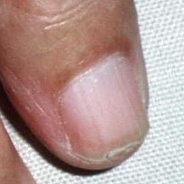 normal#1265 **Confidences:**normal = 98%; non-serious = 1%; warrants second opinion = 0%;   
The nail's condition is normal with confidence score of 98%.  
Otherwise it is non-serious with confidence score of 1%.×

 normal#870 **Confidences:**normal = 98%; non-serious = 1%; warrants second opinion = 1%;   
The nail's condition is normal with confidence score of 98%.  
Otherwise it is non-serious with confidence score of 1%.×

 normal#760 **Confidences:**normal = 98%; non-serious = 2%; warrants second opinion = 0%;   
The nail's condition is normal with confidence score of 98%.  
Otherwise it is non-serious with confidence score of 2%.×

 normal#110 **Confidences:**normal = 98%; non-serious = 0%; warrants second opinion = 2%;   
The nail's condition is normal with confidence score of 98%.  
The confidence score for it warranting a second opinion is 2%.×

 normal#970 **Confidences:**normal = 99%; non-serious = 0%; warrants second opinion = 1%;   
The nail's condition is normal with confidence score of 99%.  
The confidence score for it warranting a second opinion is 1%.×

 normal#770 **Confidences:**normal = 99%; non-serious = 0%; warrants second opinion = 1%;   
The nail's condition is normal with confidence score of 99%.  
The confidence score for it warranting a second opinion is 1%.×

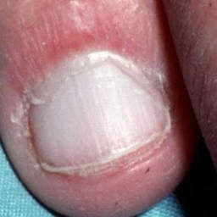 normal#1010 **Confidences:**normal = 99%; non-serious = 1%; warrants second opinion = 0%;   
The nail's condition is normal with confidence score of 99%.  
Otherwise it is non-serious with confidence score of 1%.×

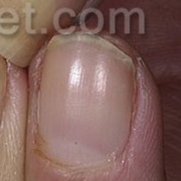 normal#1150 **Confidences:**normal = 99%; non-serious = 1%; warrants second opinion = 0%;   
The nail's condition is normal with confidence score of 99%.  
Otherwise it is non-serious with confidence score of 1%.×

 normal#695 **Confidences:**normal = 99%; non-serious = 1%; warrants second opinion = 0%;   
The nail's condition is normal with confidence score of 99%.  
Otherwise it is non-serious with confidence score of 1%.×

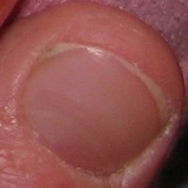 normal#1330 **Confidences:**normal = 99%; non-serious = 1%; warrants second opinion = 0%;   
The nail's condition is normal with confidence score of 99%.  
Otherwise it is non-serious with confidence score of 1%.×

 normal#360 **Confidences:**normal = 99%; non-serious = 0%; warrants second opinion = 1%;   
The nail's condition is normal with confidence score of 99%.  
The confidence score for it warranting a second opinion is 1%.×

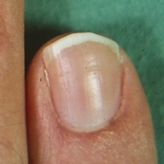 normal#1195 **Confidences:**normal = 99%; non-serious = 1%; warrants second opinion = 0%;   
The nail's condition is normal with confidence score of 99%.  
Otherwise it is non-serious with confidence score of 1%.×

 normal#725 **Confidences:**normal = 99%; non-serious = 0%; warrants second opinion = 1%;   
The nail's condition is normal with confidence score of 99%.  
The confidence score for it warranting a second opinion is 1%.×

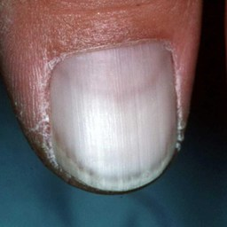 normal#1210 **Confidences:**normal = 99%; non-serious = 1%; warrants second opinion = 0%;   
The nail's condition is normal with confidence score of 99%.  
Otherwise it is non-serious with confidence score of 1%.×

 normal#130 **Confidences:**normal = 99%; non-serious = 0%; warrants second opinion = 1%;   
The nail's condition is normal with confidence score of 99%.  
The confidence score for it warranting a second opinion is 1%.×

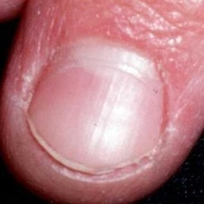 normal#1015 **Confidences:**normal = 99%; non-serious = 0%; warrants second opinion = 1%;   
The nail's condition is normal with confidence score of 99%.  
The confidence score for it warranting a second opinion is 1%.×

 normal#720 **Confidences:**normal = 99%; non-serious = 0%; warrants second opinion = 1%;   
The nail's condition is normal with confidence score of 99%.  
The confidence score for it warranting a second opinion is 1%.×

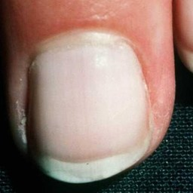 normal#1035 **Confidences:**normal = 99%; non-serious = 0%; warrants second opinion = 1%;   
The nail's condition is normal with confidence score of 99%.  
The confidence score for it warranting a second opinion is 1%.×

 normal#960 **Confidences:**normal = 99%; non-serious = 1%; warrants second opinion = 0%;   
The nail's condition is normal with confidence score of 99%.  
Otherwise it is non-serious with confidence score of 1%.×

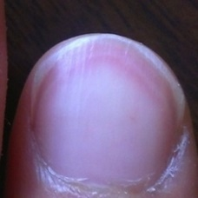 normal#1325 **Confidences:**normal = 99%; non-serious = 0%; warrants second opinion = 1%;   
The nail's condition is normal with confidence score of 99%.  
The confidence score for it warranting a second opinion is 1%.×

 normal#170 **Confidences:**normal = 99%; non-serious = 1%; warrants second opinion = 0%;   
The nail's condition is normal with confidence score of 99%.  
Otherwise it is non-serious with confidence score of 1%.×

 normal#585 **Confidences:**normal = 99%; non-serious = 0%; warrants second opinion = 1%;   
The nail's condition is normal with confidence score of 99%.  
The confidence score for it warranting a second opinion is 1%.×

 normal#75 **Confidences:**normal = 99%; non-serious = 0%; warrants second opinion = 1%;   
The nail's condition is normal with confidence score of 99%.  
The confidence score for it warranting a second opinion is 1%.×

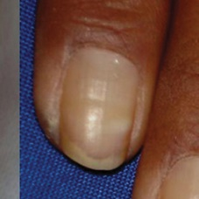 normal#1175 **Confidences:**normal = 99%; non-serious = 0%; warrants second opinion = 1%;   
The nail's condition is normal with confidence score of 99%.  
The confidence score for it warranting a second opinion is 1%.×

 normal#330 **Confidences:**normal = 99%; non-serious = 0%; warrants second opinion = 1%;   
The nail's condition is normal with confidence score of 99%.  
The confidence score for it warranting a second opinion is 1%.×

 normal#610 **Confidences:**normal = 99%; non-serious = 0%; warrants second opinion = 0%;   
The nail's condition is normal with confidence score of 99%.×

 normal#595 **Confidences:**normal = 99%; non-serious = 1%; warrants second opinion = 0%;   
The nail's condition is normal with confidence score of 99%.  
Otherwise it is non-serious with confidence score of 1%.×

 normal#965 **Confidences:**normal = 99%; non-serious = 0%; warrants second opinion = 1%;   
The nail's condition is normal with confidence score of 99%.  
The confidence score for it warranting a second opinion is 1%.×

 normal#935 **Confidences:**normal = 99%; non-serious = 0%; warrants second opinion = 0%;   
The nail's condition is normal with confidence score of 99%.×

 normal#245 **Confidences:**normal = 99%; non-serious = 0%; warrants second opinion = 0%;   
The nail's condition is normal with confidence score of 99%.×

 normal#630 **Confidences:**normal = 99%; non-serious = 0%; warrants second opinion = 1%;   
The nail's condition is normal with confidence score of 99%.  
The confidence score for it warranting a second opinion is 1%.×

 normal#975 **Confidences:**normal = 99%; non-serious = 1%; warrants second opinion = 0%;   
The nail's condition is normal with confidence score of 99%.  
Otherwise it is non-serious with confidence score of 1%.×

 normal#490 **Confidences:**normal = 99%; non-serious = 0%; warrants second opinion = 0%;   
The nail's condition is normal with confidence score of 99%.×

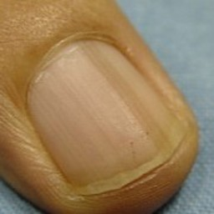 normal#1360 **Confidences:**normal = 99%; non-serious = 0%; warrants second opinion = 1%;   
The nail's condition is normal with confidence score of 99%.  
The confidence score for it warranting a second opinion is 1%.×

 normal#45 **Confidences:**normal = 99%; non-serious = 0%; warrants second opinion = 1%;   
The nail's condition is normal with confidence score of 99%.  
The confidence score for it warranting a second opinion is 1%.×

 normal#840 **Confidences:**normal = 99%; non-serious = 0%; warrants second opinion = 1%;   
The nail's condition is normal with confidence score of 99%.  
The confidence score for it warranting a second opinion is 1%.×

 normal#425 **Confidences:**normal = 99%; non-serious = 0%; warrants second opinion = 0%;   
The nail's condition is normal with confidence score of 99%.×

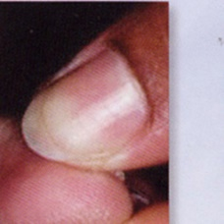 normal#1365 **Confidences:**normal = 99%; non-serious = 0%; warrants second opinion = 0%;   
The nail's condition is normal with confidence score of 99%.×

 normal#215 **Confidences:**normal = 99%; non-serious = 1%; warrants second opinion = 0%;   
The nail's condition is normal with confidence score of 99%.  
Otherwise it is non-serious with confidence score of 1%.×

 normal#60 **Confidences:**normal = 99%; non-serious = 0%; warrants second opinion = 0%;   
The nail's condition is normal with confidence score of 99%.×

 normal#525 **Confidences:**normal = 100%; non-serious = 0%; warrants second opinion = 0%;   
The nail's condition is normal with confidence score of 100%.×

 normal#385 **Confidences:**normal = 100%; non-serious = 0%; warrants second opinion = 0%;   
The nail's condition is normal with confidence score of 100%.×

 normal#480 **Confidences:**normal = 100%; non-serious = 0%; warrants second opinion = 0%;   
The nail's condition is normal with confidence score of 100%.×

 normal#755 **Confidences:**normal = 100%; non-serious = 0%; warrants second opinion = 0%;   
The nail's condition is normal with confidence score of 100%.×

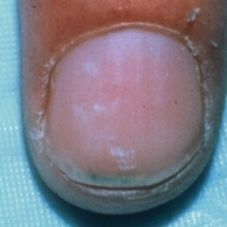 normal#1180 **Confidences:**normal = 100%; non-serious = 0%; warrants second opinion = 0%;   
The nail's condition is normal with confidence score of 100%.×

 normal#515 **Confidences:**normal = 100%; non-serious = 0%; warrants second opinion = 0%;   
The nail's condition is normal with confidence score of 100%.×

 normal#545 **Confidences:**normal = 100%; non-serious = 0%; warrants second opinion = 0%;   
The nail's condition is normal with confidence score of 100%.×

 normal#700 **Confidences:**normal = 100%; non-serious = 0%; warrants second opinion = 0%;   
The nail's condition is normal with confidence score of 100%.×

 normal#270 **Confidences:**normal = 100%; non-serious = 0%; warrants second opinion = 0%;   
The nail's condition is normal with confidence score of 100%.×

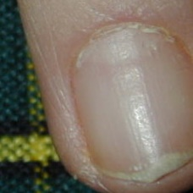 normal#1025 **Confidences:**normal = 100%; non-serious = 0%; warrants second opinion = 0%;   
The nail's condition is normal with confidence score of 100%.×

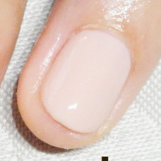 normal#1295 **Confidences:**normal = 100%; non-serious = 0%; warrants second opinion = 0%;   
The nail's condition is normal with confidence score of 100%.×

 normal#445 **Confidences:**normal = 100%; non-serious = 0%; warrants second opinion = 0%;   
The nail's condition is normal with confidence score of 100%.×

 normal#780 **Confidences:**normal = 100%; non-serious = 0%; warrants second opinion = 0%;   
The nail's condition is normal with confidence score of 100%.×

 normal#560 **Confidences:**normal = 100%; non-serious = 0%; warrants second opinion = 0%;   
The nail's condition is normal with confidence score of 100%.×

 normal#575 **Confidences:**normal = 100%; non-serious = 0%; warrants second opinion = 0%;   
The nail's condition is normal with confidence score of 100%.×

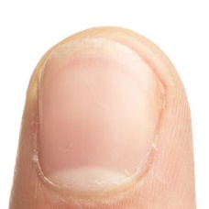 normal#1090 **Confidences:**normal = 100%; non-serious = 0%; warrants second opinion = 0%;   
The nail's condition is normal with confidence score of 100%.×

 normal#420 **Confidences:**normal = 100%; non-serious = 0%; warrants second opinion = 0%;   
The nail's condition is normal with confidence score of 100%.×

 normal#375 **Confidences:**normal = 100%; non-serious = 0%; warrants second opinion = 0%;   
The nail's condition is normal with confidence score of 100%.×

 normal#500 **Confidences:**normal = 100%; non-serious = 0%; warrants second opinion = 0%;   
The nail's condition is normal with confidence score of 100%.×

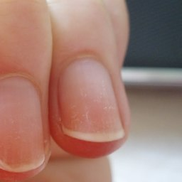 normal#1170 **Confidences:**normal = 100%; non-serious = 0%; warrants second opinion = 0%;   
The nail's condition is normal with confidence score of 100%.×

 normal#300 **Confidences:**normal = 100%; non-serious = 0%; warrants second opinion = 0%;   
The nail's condition is normal with confidence score of 100%.×

 normal#155 **Confidences:**normal = 100%; non-serious = 0%; warrants second opinion = 0%;   
The nail's condition is normal with confidence score of 100%.×

 normal#395 **Confidences:**normal = 100%; non-serious = 0%; warrants second opinion = 0%;   
The nail's condition is normal with confidence score of 100%.×

 normal#675 **Confidences:**normal = 100%; non-serious = 0%; warrants second opinion = 0%;   
The nail's condition is normal with confidence score of 100%.×

 normal#365 **Confidences:**normal = 100%; non-serious = 0%; warrants second opinion = 0%;   
The nail's condition is normal with confidence score of 100%.×

 normal#690 **Confidences:**normal = 100%; non-serious = 0%; warrants second opinion = 0%;   
The nail's condition is normal with confidence score of 100%.×

 normal#85 **Confidences:**normal = 100%; non-serious = 0%; warrants second opinion = 0%;   
The nail's condition is normal with confidence score of 100%.×

 normal#210 **Confidences:**normal = 100%; non-serious = 0%; warrants second opinion = 0%;   
The nail's condition is normal with confidence score of 100%.×

 normal#795 **Confidences:**normal = 100%; non-serious = 0%; warrants second opinion = 0%;   
The nail's condition is normal with confidence score of 100%.×

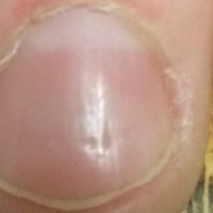 normal#1250 **Confidences:**normal = 100%; non-serious = 0%; warrants second opinion = 0%;   
The nail's condition is normal with confidence score of 100%.×

 normal#195 **Confidences:**normal = 100%; non-serious = 0%; warrants second opinion = 0%;   
The nail's condition is normal with confidence score of 100%.×

 normal#165 **Confidences:**normal = 100%; non-serious = 0%; warrants second opinion = 0%;   
The nail's condition is normal with confidence score of 100%.×

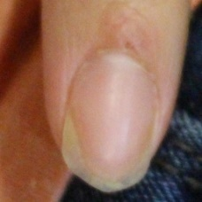 normal#1355 **Confidences:**normal = 100%; non-serious = 0%; warrants second opinion = 0%;   
The nail's condition is normal with confidence score of 100%.×

 normal#305 **Confidences:**normal = 100%; non-serious = 0%; warrants second opinion = 0%;   
The nail's condition is normal with confidence score of 100%.×

 normal#400 **Confidences:**normal = 100%; non-serious = 0%; warrants second opinion = 0%;   
The nail's condition is normal with confidence score of 100%.×

 normal#895 **Confidences:**normal = 100%; non-serious = 0%; warrants second opinion = 0%;   
The nail's condition is normal with confidence score of 100%.×

 normal#980 **Confidences:**normal = 100%; non-serious = 0%; warrants second opinion = 0%;   
The nail's condition is normal with confidence score of 100%.×

 normal#570 **Confidences:**normal = 100%; non-serious = 0%; warrants second opinion = 0%;   
The nail's condition is normal with confidence score of 100%.×

 normal#455 **Confidences:**normal = 100%; non-serious = 0%; warrants second opinion = 0%;   
The nail's condition is normal with confidence score of 100%.×

 normal#235 **Confidences:**normal = 100%; non-serious = 0%; warrants second opinion = 0%;   
The nail's condition is normal with confidence score of 100%.×

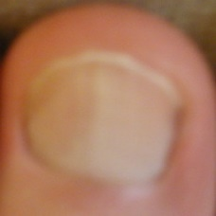 normal#1300 **Confidences:**normal = 100%; non-serious = 0%; warrants second opinion = 0%;   
The nail's condition is normal with confidence score of 100%.×

 normal#80 **Confidences:**normal = 100%; non-serious = 0%; warrants second opinion = 0%;   
The nail's condition is normal with confidence score of 100%.×

 normal#140 **Confidences:**normal = 100%; non-serious = 0%; warrants second opinion = 0%;   
The nail's condition is normal with confidence score of 100%.×

 normal#115 **Confidences:**normal = 100%; non-serious = 0%; warrants second opinion = 0%;   
The nail's condition is normal with confidence score of 100%.×

 normal#55 **Confidences:**normal = 100%; non-serious = 0%; warrants second opinion = 0%;   
The nail's condition is normal with confidence score of 100%.×

 normal#920 **Confidences:**normal = 100%; non-serious = 0%; warrants second opinion = 0%;   
The nail's condition is normal with confidence score of 100%.×

 normal#990 **Confidences:**normal = 100%; non-serious = 0%; warrants second opinion = 0%;   
The nail's condition is normal with confidence score of 100%.×

 normal#370 **Confidences:**normal = 100%; non-serious = 0%; warrants second opinion = 0%;   
The nail's condition is normal with confidence score of 100%.×

 normal#855 **Confidences:**normal = 100%; non-serious = 0%; warrants second opinion = 0%;   
The nail's condition is normal with confidence score of 100%.×

 normal#320 **Confidences:**normal = 100%; non-serious = 0%; warrants second opinion = 0%;   
The nail's condition is normal with confidence score of 100%.×

 normal#815 **Confidences:**normal = 100%; non-serious = 0%; warrants second opinion = 0%;   
The nail's condition is normal with confidence score of 100%.×

 normal#120 **Confidences:**normal = 100%; non-serious = 0%; warrants second opinion = 0%;   
The nail's condition is normal with confidence score of 100%.×

 normal#800 **Confidences:**normal = 100%; non-serious = 0%; warrants second opinion = 0%;   
The nail's condition is normal with confidence score of 100%.×

 normal#510 **Confidences:**normal = 100%; non-serious = 0%; warrants second opinion = 0%;   
The nail's condition is normal with confidence score of 100%.×

 normal#435 **Confidences:**normal = 100%; non-serious = 0%; warrants second opinion = 0%;   
The nail's condition is normal with confidence score of 100%.×

 normal#830 **Confidences:**normal = 100%; non-serious = 0%; warrants second opinion = 0%;   
The nail's condition is normal with confidence score of 100%.×

 normal#640 **Confidences:**normal = 100%; non-serious = 0%; warrants second opinion = 0%;   
The nail's condition is normal with confidence score of 100%.×

 normal#625 **Confidences:**normal = 100%; non-serious = 0%; warrants second opinion = 0%;   
The nail's condition is normal with confidence score of 100%.×

 normal#655 **Confidences:**normal = 100%; non-serious = 0%; warrants second opinion = 0%;   
The nail's condition is normal with confidence score of 100%.×

 normal#1000 **Confidences:**normal = 100%; non-serious = 0%; warrants second opinion = 0%;   
The nail's condition is normal with confidence score of 100%.×

 normal#615 **Confidences:**normal = 100%; non-serious = 0%; warrants second opinion = 0%;   
The nail's condition is normal with confidence score of 100%.×

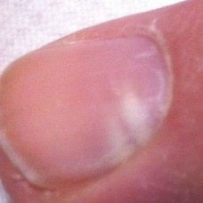 normal#1145 **Confidences:**normal = 100%; non-serious = 0%; warrants second opinion = 0%;   
The nail's condition is normal with confidence score of 100%.×

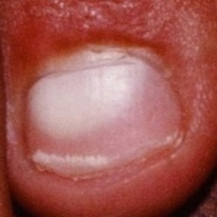 normal#1255 **Confidences:**normal = 100%; non-serious = 0%; warrants second opinion = 0%;   
The nail's condition is normal with confidence score of 100%.×

 normal#65 **Confidences:**normal = 100%; non-serious = 0%; warrants second opinion = 0%;   
The nail's condition is normal with confidence score of 100%.×

 normal#25 **Confidences:**normal = 100%; non-serious = 0%; warrants second opinion = 0%;   
The nail's condition is normal with confidence score of 100%.×

 normal#820 **Confidences:**normal = 100%; non-serious = 0%; warrants second opinion = 0%;   
The nail's condition is normal with confidence score of 100%.×

 normal#910 **Confidences:**normal = 100%; non-serious = 0%; warrants second opinion = 0%;   
The nail's condition is normal with confidence score of 100%.×

 normal#355 **Confidences:**normal = 100%; non-serious = 0%; warrants second opinion = 0%;   
The nail's condition is normal with confidence score of 100%.×

 normal#50 **Confidences:**normal = 100%; non-serious = 0%; warrants second opinion = 0%;   
The nail's condition is normal with confidence score of 100%.×

 normal#950 **Confidences:**normal = 100%; non-serious = 0%; warrants second opinion = 0%;   
The nail's condition is normal with confidence score of 100%.×

 normal#750 **Confidences:**normal = 100%; non-serious = 0%; warrants second opinion = 0%;   
The nail's condition is normal with confidence score of 100%.×

 normal#715 **Confidences:**normal = 100%; non-serious = 0%; warrants second opinion = 0%;   
The nail's condition is normal with confidence score of 100%.×

 normal#685 **Confidences:**normal = 100%; non-serious = 0%; warrants second opinion = 0%;   
The nail's condition is normal with confidence score of 100%.×

 normal#495 **Confidences:**normal = 100%; non-serious = 0%; warrants second opinion = 0%;   
The nail's condition is normal with confidence score of 100%.×

 normal#995 **Confidences:**normal = 100%; non-serious = 0%; warrants second opinion = 0%;   
The nail's condition is normal with confidence score of 100%.×

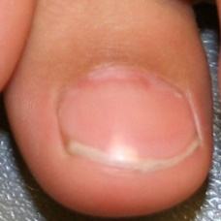 normal#1040 **Confidences:**normal = 100%; non-serious = 0%; warrants second opinion = 0%;   
The nail's condition is normal with confidence score of 100%.×

 normal#1205 **Confidences:**normal = 100%; non-serious = 0%; warrants second opinion = 0%;   
The nail's condition is normal with confidence score of 100%.×

 normal#535 **Confidences:**normal = 100%; non-serious = 0%; warrants second opinion = 0%;   
The nail's condition is normal with confidence score of 100%.×

 normal#705 **Confidences:**normal = 100%; non-serious = 0%; warrants second opinion = 0%;   
The nail's condition is normal with confidence score of 100%.×

 normal#580 **Confidences:**normal = 100%; non-serious = 0%; warrants second opinion = 0%;   
The nail's condition is normal with confidence score of 100%.×

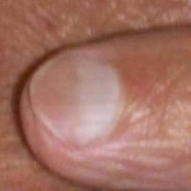 normal#1235 **Confidences:**normal = 100%; non-serious = 0%; warrants second opinion = 0%;   
The nail's condition is normal with confidence score of 100%.×

 normal#590 **Confidences:**normal = 100%; non-serious = 0%; warrants second opinion = 0%;   
The nail's condition is normal with confidence score of 100%.×

 normal#390 **Confidences:**normal = 100%; non-serious = 0%; warrants second opinion = 0%;   
The nail's condition is normal with confidence score of 100%.×

 normal#520 **Confidences:**normal = 100%; non-serious = 0%; warrants second opinion = 0%;   
The nail's condition is normal with confidence score of 100%.×

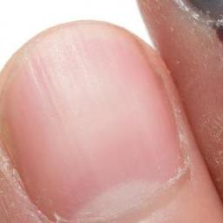 normal#1050 **Confidences:**normal = 100%; non-serious = 0%; warrants second opinion = 0%;   
The nail's condition is normal with confidence score of 100%.×

 normal#1155 **Confidences:**normal = 100%; non-serious = 0%; warrants second opinion = 0%;   
The nail's condition is normal with confidence score of 100%.×

 normal#465 **Confidences:**normal = 100%; non-serious = 0%; warrants second opinion = 0%;   
The nail's condition is normal with confidence score of 100%.×

 normal#930 **Confidences:**normal = 100%; non-serious = 0%; warrants second opinion = 0%;   
The nail's condition is normal with confidence score of 100%.×

 normal#765 **Confidences:**normal = 100%; non-serious = 0%; warrants second opinion = 0%;   
The nail's condition is normal with confidence score of 100%.×

 normal#915 **Confidences:**normal = 100%; non-serious = 0%; warrants second opinion = 0%;   
The nail's condition is normal with confidence score of 100%.×

 normal#240 **Confidences:**normal = 100%; non-serious = 0%; warrants second opinion = 0%;   
The nail's condition is normal with confidence score of 100%.×

 normal#905 **Confidences:**normal = 100%; non-serious = 0%; warrants second opinion = 0%;   
The nail's condition is normal with confidence score of 100%.×

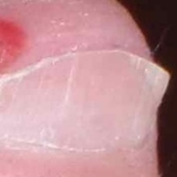 non-serious#1178 **Confidences:**normal = 100%; non-serious = 0%; warrants second opinion = 0%;   
The nail's condition is normal with confidence score of 100%.×

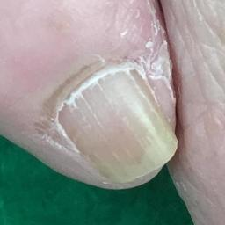 non-serious#1528 **Confidences:**normal = 100%; non-serious = 0%; warrants second opinion = 0%;   
The nail's condition is normal with confidence score of 100%.×

 non-serious#833 **Confidences:**normal = 98%; non-serious = 1%; warrants second opinion = 1%;   
The nail's condition is normal with confidence score of 98%.  
Otherwise it is non-serious with confidence score of 1%.×

 non-serious#193 **Confidences:**normal = 18%; non-serious = 1%; warrants second opinion = 81%;   
It is most likely that the nail indicates something that warrants a second opinion and you should seek medical advice. (Confidence score is 81%)×

 non-serious#918 **Confidences:**normal = 87%; non-serious = 2%; warrants second opinion = 11%;   
The nail's condition is normal with confidence score of 87%.  
The confidence score for it warranting a second opinion is 11%.×

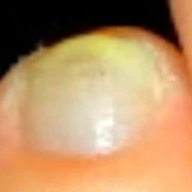 non-serious#1523 **Confidences:**normal = 92%; non-serious = 3%; warrants second opinion = 6%;   
The nail's condition is normal with confidence score of 92%.  
The confidence score for it warranting a second opinion is 6%.×

 non-serious#208 **Confidences:**normal = 0%; non-serious = 3%; warrants second opinion = 97%;   
It is most likely that the nail indicates something that warrants a second opinion and you should seek medical advice. (Confidence score is 97%)×

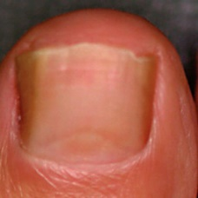 non-serious#1168 **Confidences:**normal = 15%; non-serious = 6%; warrants second opinion = 79%;   
It is most likely that the nail indicates something that warrants a second opinion and you should seek medical advice. (Confidence score is 79%)×

 non-serious#198 **Confidences:**normal = 2%; non-serious = 7%; warrants second opinion = 91%;   
It is most likely that the nail indicates something that warrants a second opinion and you should seek medical advice. (Confidence score is 91%)×

 non-serious#113 **Confidences:**normal = 90%; non-serious = 8%; warrants second opinion = 2%;   
The nail's condition is normal with confidence score of 90%.  
Otherwise it is non-serious with confidence score of 8%.×

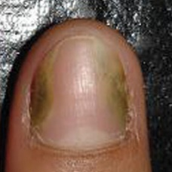 non-serious#1143 **Confidences:**normal = 84%; non-serious = 12%; warrants second opinion = 4%;   
The nail's condition is normal with confidence score of 84%.  
Otherwise it is non-serious with confidence score of 12%.×

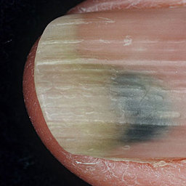 non-serious#1478 **Confidences:**normal = 0%; non-serious = 15%; warrants second opinion = 85%;   
It is most likely that the nail indicates something that warrants a second opinion and you should seek medical advice. (Confidence score is 85%)×

 non-serious#153 **Confidences:**normal = 0%; non-serious = 19%; warrants second opinion = 81%;   
It is most likely that the nail indicates something that warrants a second opinion and you should seek medical advice. (Confidence score is 81%)×

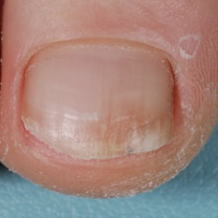 non-serious#1518 **Confidences:**normal = 75%; non-serious = 24%; warrants second opinion = 1%;   
The nail's condition is normal with confidence score of 75%.  
Otherwise it is non-serious with confidence score of 24%.×

 non-serious#888 **Confidences:**normal = 1%; non-serious = 25%; warrants second opinion = 75%;   
It is most likely that the nail indicates something that warrants a second opinion and you should seek medical advice. (Confidence score is 75%)×

 non-serious#903 **Confidences:**normal = 72%; non-serious = 27%; warrants second opinion = 1%;   
The nail's condition is normal with confidence score of 72%.  
Otherwise it is non-serious with confidence score of 27%.×

 non-serious#963 **Confidences:**normal = 72%; non-serious = 27%; warrants second opinion = 1%;   
The nail's condition is normal with confidence score of 72%.  
Otherwise it is non-serious with confidence score of 27%.×

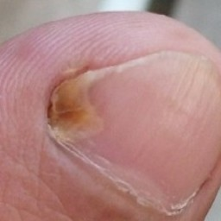 non-serious#1533 **Confidences:**normal = 72%; non-serious = 28%; warrants second opinion = 0%;   
The nail's condition is normal with confidence score of 72%.  
Otherwise it is non-serious with confidence score of 28%.×

 non-serious#248 **Confidences:**normal = 0%; non-serious = 28%; warrants second opinion = 72%;   
It is most likely that the nail indicates something that warrants a second opinion and you should seek medical advice. (Confidence score is 72%)×

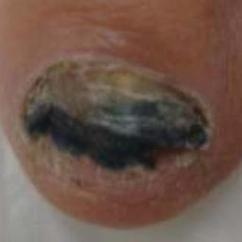 non-serious#1103 **Confidences:**normal = 44%; non-serious = 51%; warrants second opinion = 5%;   
Not very sure whether the nail is OK or not. Sorry.×

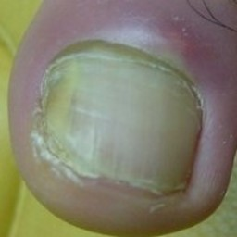 non-serious#1593 **Confidences:**normal = 6%; non-serious = 53%; warrants second opinion = 41%;   
Not very sure whether the nail is OK or not. Sorry.×

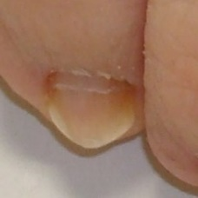 non-serious#1383 **Confidences:**normal = 13%; non-serious = 54%; warrants second opinion = 33%;   
Not very sure whether the nail is OK or not. Sorry.×

 non-serious#698 **Confidences:**normal = 0%; non-serious = 54%; warrants second opinion = 46%;   
Not very sure whether the nail is OK or not. Sorry.×

 non-serious#603 **Confidences:**normal = 0%; non-serious = 58%; warrants second opinion = 42%;   
Not very sure whether the nail is OK or not. Sorry.×

 non-serious#843 **Confidences:**normal = 1%; non-serious = 65%; warrants second opinion = 34%;   
It might be warrant a second opinion (confidence score is 34%) ×

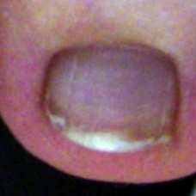 non-serious#1323 **Confidences:**normal = 32%; non-serious = 65%; warrants second opinion = 2%;   
The nail's condition is non-serious with confidence score of 65%.  
Otherwise it is normal with confidence score of 32%.×

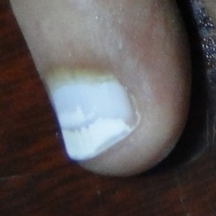 non-serious#1248 **Confidences:**normal = 34%; non-serious = 66%; warrants second opinion = 0%;   
The nail's condition is non-serious with confidence score of 66%.  
Otherwise it is normal with confidence score of 34%.×

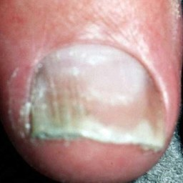 non-serious#1313 **Confidences:**normal = 33%; non-serious = 66%; warrants second opinion = 1%;   
The nail's condition is non-serious with confidence score of 66%.  
Otherwise it is normal with confidence score of 33%.×

 non-serious#428 **Confidences:**normal = 1%; non-serious = 73%; warrants second opinion = 27%;   
It might be warrant a second opinion (confidence score is 27%) ×

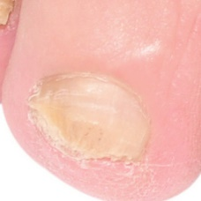 non-serious#1413 **Confidences:**normal = 27%; non-serious = 73%; warrants second opinion = 0%;   
The nail's condition is non-serious with confidence score of 73%.  
Otherwise it is normal with confidence score of 27%.×

 non-serious#408 **Confidences:**normal = 1%; non-serious = 74%; warrants second opinion = 25%;   
It might be warrant a second opinion (confidence score is 25%) ×

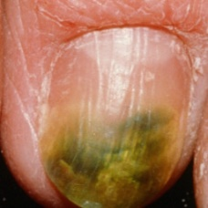 non-serious#1603 **Confidences:**normal = 0%; non-serious = 74%; warrants second opinion = 25%;   
It might be warrant a second opinion (confidence score is 25%) ×

 non-serious#163 **Confidences:**normal = 4%; non-serious = 74%; warrants second opinion = 22%;   
It might be warrant a second opinion (confidence score is 22%) ×

 non-serious#253 **Confidences:**normal = 2%; non-serious = 75%; warrants second opinion = 23%;   
It might be warrant a second opinion (confidence score is 23%) ×

 non-serious#103 **Confidences:**normal = 9%; non-serious = 76%; warrants second opinion = 15%;   
The nail's condition is non-serious with confidence score of 76%.  
The confidence score for it warranting a second opinion is 15%.×

 non-serious#853 **Confidences:**normal = 0%; non-serious = 76%; warrants second opinion = 24%;   
It might be warrant a second opinion (confidence score is 24%) ×

 non-serious#438 **Confidences:**normal = 0%; non-serious = 76%; warrants second opinion = 24%;   
It might be warrant a second opinion (confidence score is 24%) ×

 non-serious#363 **Confidences:**normal = 23%; non-serious = 77%; warrants second opinion = 0%;   
The nail's condition is non-serious with confidence score of 77%.  
Otherwise it is normal with confidence score of 23%.×

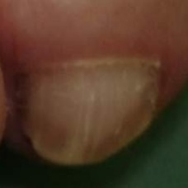 non-serious#1253 **Confidences:**normal = 17%; non-serious = 77%; warrants second opinion = 6%;   
The nail's condition is non-serious with confidence score of 77%.  
Otherwise it is normal with confidence score of 17%.×

 non-serious#38 **Confidences:**normal = 11%; non-serious = 80%; warrants second opinion = 9%;   
The nail's condition is non-serious with confidence score of 80%.  
Otherwise it is normal with confidence score of 11%.×

 non-serious#878 **Confidences:**normal = 1%; non-serious = 81%; warrants second opinion = 18%;   
The nail's condition is non-serious with confidence score of 81%.  
The confidence score for it warranting a second opinion is 18%.×

 non-serious#403 **Confidences:**normal = 3%; non-serious = 82%; warrants second opinion = 16%;   
The nail's condition is non-serious with confidence score of 82%.  
The confidence score for it warranting a second opinion is 16%.×

 non-serious#68 **Confidences:**normal = 0%; non-serious = 82%; warrants second opinion = 18%;   
The nail's condition is non-serious with confidence score of 82%.  
The confidence score for it warranting a second opinion is 18%.×

 non-serious#613 **Confidences:**normal = 16%; non-serious = 83%; warrants second opinion = 1%;   
The nail's condition is non-serious with confidence score of 83%.  
Otherwise it is normal with confidence score of 16%.×

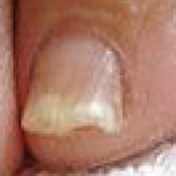 non-serious#1123 **Confidences:**normal = 2%; non-serious = 83%; warrants second opinion = 15%;   
The nail's condition is non-serious with confidence score of 83%.  
The confidence score for it warranting a second opinion is 15%.×

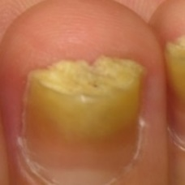 non-serious#1543 **Confidences:**normal = 15%; non-serious = 85%; warrants second opinion = 0%;   
The nail's condition is non-serious with confidence score of 85%.  
Otherwise it is normal with confidence score of 15%.×

 non-serious#778 **Confidences:**normal = 11%; non-serious = 86%; warrants second opinion = 3%;   
The nail's condition is non-serious with confidence score of 86%.  
Otherwise it is normal with confidence score of 11%.×

 non-serious#148 **Confidences:**normal = 10%; non-serious = 87%; warrants second opinion = 3%;   
The nail's condition is non-serious with confidence score of 87%.  
Otherwise it is normal with confidence score of 10%.×

 non-serious#668 **Confidences:**normal = 0%; non-serious = 88%; warrants second opinion = 12%;   
The nail's condition is non-serious with confidence score of 88%.  
The confidence score for it warranting a second opinion is 12%.×

 non-serious#693 **Confidences:**normal = 0%; non-serious = 88%; warrants second opinion = 12%;   
The nail's condition is non-serious with confidence score of 88%.  
The confidence score for it warranting a second opinion is 12%.×

 non-serious#398 **Confidences:**normal = 0%; non-serious = 88%; warrants second opinion = 12%;   
The nail's condition is non-serious with confidence score of 88%.  
The confidence score for it warranting a second opinion is 12%.×

 non-serious#913 **Confidences:**normal = 11%; non-serious = 89%; warrants second opinion = 1%;   
The nail's condition is non-serious with confidence score of 89%.  
Otherwise it is normal with confidence score of 11%.×

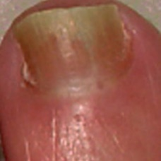 non-serious#1173 **Confidences:**normal = 5%; non-serious = 89%; warrants second opinion = 6%;   
The nail's condition is non-serious with confidence score of 89%.  
The confidence score for it warranting a second opinion is 6%.×

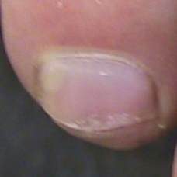 non-serious#1333 **Confidences:**normal = 10%; non-serious = 89%; warrants second opinion = 1%;   
The nail's condition is non-serious with confidence score of 89%.  
Otherwise it is normal with confidence score of 10%.×

 non-serious#988 **Confidences:**normal = 5%; non-serious = 90%; warrants second opinion = 6%;   
The nail's condition is non-serious with confidence score of 90%.  
The confidence score for it warranting a second opinion is 6%.×

 non-serious#513 **Confidences:**normal = 3%; non-serious = 90%; warrants second opinion = 8%;   
The nail's condition is non-serious with confidence score of 90%.  
The confidence score for it warranting a second opinion is 8%.×

 non-serious#423 **Confidences:**normal = 4%; non-serious = 91%; warrants second opinion = 6%;   
The nail's condition is non-serious with confidence score of 91%.  
The confidence score for it warranting a second opinion is 6%.×

 non-serious#388 **Confidences:**normal = 1%; non-serious = 91%; warrants second opinion = 8%;   
The nail's condition is non-serious with confidence score of 91%.  
The confidence score for it warranting a second opinion is 8%.×

 non-serious#293 **Confidences:**normal = 9%; non-serious = 91%; warrants second opinion = 0%;   
The nail's condition is non-serious with confidence score of 91%.  
Otherwise it is normal with confidence score of 9%.×

 non-serious#678 **Confidences:**normal = 6%; non-serious = 91%; warrants second opinion = 3%;   
The nail's condition is non-serious with confidence score of 91%.  
Otherwise it is normal with confidence score of 6%.×

 non-serious#608 **Confidences:**normal = 1%; non-serious = 92%; warrants second opinion = 8%;   
The nail's condition is non-serious with confidence score of 92%.  
The confidence score for it warranting a second opinion is 8%.×

 non-serious#383 **Confidences:**normal = 1%; non-serious = 92%; warrants second opinion = 8%;   
The nail's condition is non-serious with confidence score of 92%.  
The confidence score for it warranting a second opinion is 8%.×

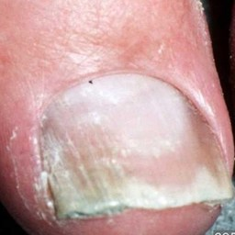 non-serious#1058 **Confidences:**normal = 5%; non-serious = 94%; warrants second opinion = 1%;   
The nail's condition is non-serious with confidence score of 94%.  
Otherwise it is normal with confidence score of 5%.×

 non-serious#703 **Confidences:**normal = 4%; non-serious = 94%; warrants second opinion = 2%;   
The nail's condition is non-serious with confidence score of 94%.  
Otherwise it is normal with confidence score of 4%.×

 non-serious#73 **Confidences:**normal = 1%; non-serious = 94%; warrants second opinion = 6%;   
The nail's condition is non-serious with confidence score of 94%.  
The confidence score for it warranting a second opinion is 6%.×

 non-serious#708 **Confidences:**normal = 2%; non-serious = 94%; warrants second opinion = 4%;   
The nail's condition is non-serious with confidence score of 94%.  
The confidence score for it warranting a second opinion is 4%.×

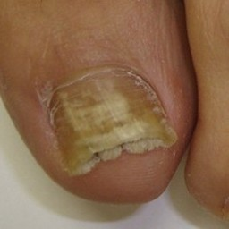 non-serious#1468 **Confidences:**normal = 1%; non-serious = 94%; warrants second opinion = 4%;   
The nail's condition is non-serious with confidence score of 94%.  
The confidence score for it warranting a second opinion is 4%.×

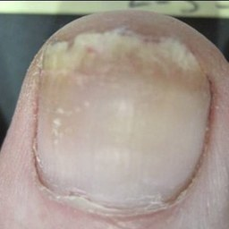 non-serious#1228 **Confidences:**normal = 3%; non-serious = 94%; warrants second opinion = 2%;   
The nail's condition is non-serious with confidence score of 94%.  
Otherwise it is normal with confidence score of 3%.×

 non-serious#463 **Confidences:**normal = 5%; non-serious = 95%; warrants second opinion = 1%;   
The nail's condition is non-serious with confidence score of 95%.  
Otherwise it is normal with confidence score of 5%.×

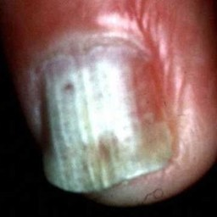 non-serious#1483 **Confidences:**normal = 2%; non-serious = 95%; warrants second opinion = 3%;   
The nail's condition is non-serious with confidence score of 95%.  
The confidence score for it warranting a second opinion is 3%.×

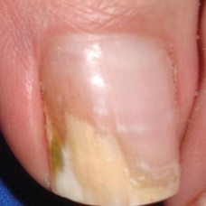 non-serious#1298 **Confidences:**normal = 1%; non-serious = 95%; warrants second opinion = 3%;   
The nail's condition is non-serious with confidence score of 95%.  
The confidence score for it warranting a second opinion is 3%.×

 non-serious#508 **Confidences:**normal = 0%; non-serious = 96%; warrants second opinion = 4%;   
The nail's condition is non-serious with confidence score of 96%.  
The confidence score for it warranting a second opinion is 4%.×

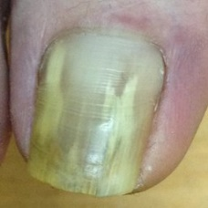 non-serious#1113 **Confidences:**normal = 0%; non-serious = 96%; warrants second opinion = 4%;   
The nail's condition is non-serious with confidence score of 96%.  
The confidence score for it warranting a second opinion is 4%.×

 non-serious#588 **Confidences:**normal = 2%; non-serious = 96%; warrants second opinion = 2%;   
The nail's condition is non-serious with confidence score of 96%.  
Otherwise it is normal with confidence score of 2%.×

 non-serious#828 **Confidences:**normal = 0%; non-serious = 96%; warrants second opinion = 4%;   
The nail's condition is non-serious with confidence score of 96%.  
The confidence score for it warranting a second opinion is 4%.×

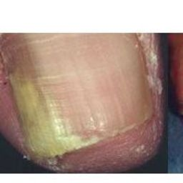 non-serious#1218 **Confidences:**normal = 1%; non-serious = 96%; warrants second opinion = 3%;   
The nail's condition is non-serious with confidence score of 96%.  
The confidence score for it warranting a second opinion is 3%.×

 non-serious#188 **Confidences:**normal = 2%; non-serious = 97%; warrants second opinion = 1%;   
The nail's condition is non-serious with confidence score of 97%.  
Otherwise it is normal with confidence score of 2%.×

 non-serious#303 **Confidences:**normal = 0%; non-serious = 97%; warrants second opinion = 3%;   
The nail's condition is non-serious with confidence score of 97%.  
The confidence score for it warranting a second opinion is 3%.×

 non-serious#323 **Confidences:**normal = 0%; non-serious = 97%; warrants second opinion = 3%;   
The nail's condition is non-serious with confidence score of 97%.  
The confidence score for it warranting a second opinion is 3%.×

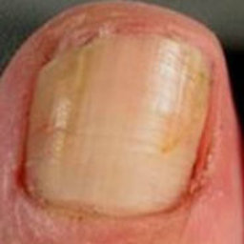 non-serious#1068 **Confidences:**normal = 0%; non-serious = 97%; warrants second opinion = 3%;   
The nail's condition is non-serious with confidence score of 97%.  
The confidence score for it warranting a second opinion is 3%.×

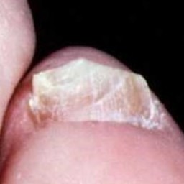 non-serious#1388 **Confidences:**normal = 3%; non-serious = 97%; warrants second opinion = 0%;   
The nail's condition is non-serious with confidence score of 97%.  
Otherwise it is normal with confidence score of 3%.×

 non-serious#298 **Confidences:**normal = 1%; non-serious = 97%; warrants second opinion = 2%;   
The nail's condition is non-serious with confidence score of 97%.  
The confidence score for it warranting a second opinion is 2%.×

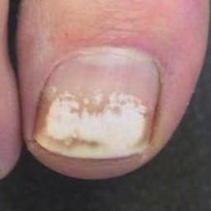 non-serious#1203 **Confidences:**normal = 3%; non-serious = 97%; warrants second opinion = 0%;   
The nail's condition is non-serious with confidence score of 97%.  
Otherwise it is normal with confidence score of 3%.×

 non-serious#503 **Confidences:**normal = 3%; non-serious = 97%; warrants second opinion = 0%;   
The nail's condition is non-serious with confidence score of 97%.  
Otherwise it is normal with confidence score of 3%.×

 non-serious#798 **Confidences:**normal = 0%; non-serious = 97%; warrants second opinion = 3%;   
The nail's condition is non-serious with confidence score of 97%.  
The confidence score for it warranting a second opinion is 3%.×

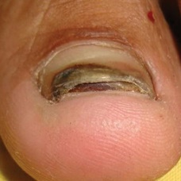 non-serious#1303 **Confidences:**normal = 2%; non-serious = 98%; warrants second opinion = 1%;   
The nail's condition is non-serious with confidence score of 98%.  
Otherwise it is normal with confidence score of 2%.×

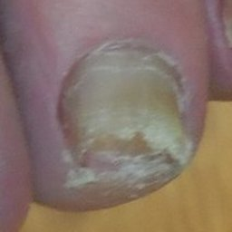 non-serious#1348 **Confidences:**normal = 2%; non-serious = 98%; warrants second opinion = 0%;   
The nail's condition is non-serious with confidence score of 98%.  
Otherwise it is normal with confidence score of 2%.×

 non-serious#58 **Confidences:**normal = 0%; non-serious = 98%; warrants second opinion = 2%;   
The nail's condition is non-serious with confidence score of 98%.  
The confidence score for it warranting a second opinion is 2%.×

 non-serious#598 **Confidences:**normal = 0%; non-serious = 98%; warrants second opinion = 2%;   
The nail's condition is non-serious with confidence score of 98%.  
The confidence score for it warranting a second opinion is 2%.×

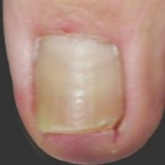 non-serious#1018 **Confidences:**normal = 2%; non-serious = 98%; warrants second opinion = 0%;   
The nail's condition is non-serious with confidence score of 98%.  
Otherwise it is normal with confidence score of 2%.×

 non-serious#813 **Confidences:**normal = 0%; non-serious = 98%; warrants second opinion = 2%;   
The nail's condition is non-serious with confidence score of 98%.  
The confidence score for it warranting a second opinion is 2%.×

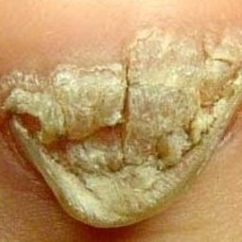 non-serious#1013 **Confidences:**normal = 0%; non-serious = 98%; warrants second opinion = 2%;   
The nail's condition is non-serious with confidence score of 98%.  
The confidence score for it warranting a second opinion is 2%.×

 non-serious#583 **Confidences:**normal = 2%; non-serious = 98%; warrants second opinion = 0%;   
The nail's condition is non-serious with confidence score of 98%.  
Otherwise it is normal with confidence score of 2%.×

 non-serious#633 **Confidences:**normal = 0%; non-serious = 98%; warrants second opinion = 2%;   
The nail's condition is non-serious with confidence score of 98%.  
The confidence score for it warranting a second opinion is 2%.×

 non-serious#418 **Confidences:**normal = 1%; non-serious = 98%; warrants second opinion = 1%;   
The nail's condition is non-serious with confidence score of 98%.  
Otherwise it is normal with confidence score of 1%.×

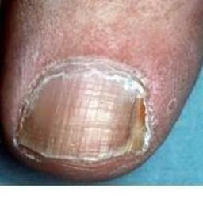 non-serious#1053 **Confidences:**normal = 1%; non-serious = 98%; warrants second opinion = 1%;   
The nail's condition is non-serious with confidence score of 98%.  
Otherwise it is normal with confidence score of 1%.×

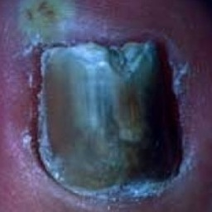 non-serious#1043 **Confidences:**normal = 0%; non-serious = 98%; warrants second opinion = 2%;   
The nail's condition is non-serious with confidence score of 98%.  
The confidence score for it warranting a second opinion is 2%.×

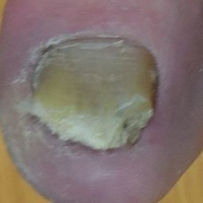 non-serious#1108 **Confidences:**normal = 1%; non-serious = 98%; warrants second opinion = 1%;   
The nail's condition is non-serious with confidence score of 98%.  
Otherwise it is normal with confidence score of 1%.×

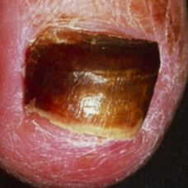 non-serious#1268 **Confidences:**normal = 0%; non-serious = 98%; warrants second opinion = 1%;   
The nail's condition is non-serious with confidence score of 98%.  
The confidence score for it warranting a second opinion is 1%.×

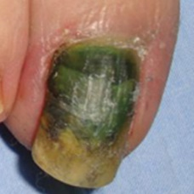 non-serious#1338 **Confidences:**normal = 0%; non-serious = 98%; warrants second opinion = 2%;   
The nail's condition is non-serious with confidence score of 98%.  
The confidence score for it warranting a second opinion is 2%.×

 non-serious#548 **Confidences:**normal = 1%; non-serious = 98%; warrants second opinion = 1%;   
The nail's condition is non-serious with confidence score of 98%.  
Otherwise it is normal with confidence score of 1%.×

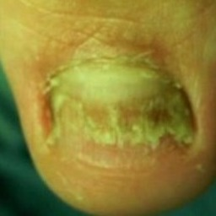 non-serious#1553 **Confidences:**normal = 0%; non-serious = 98%; warrants second opinion = 1%;   
The nail's condition is non-serious with confidence score of 98%.  
The confidence score for it warranting a second opinion is 1%.×

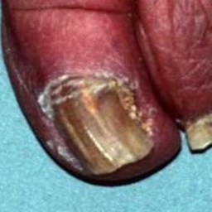 non-serious#1293 **Confidences:**normal = 0%; non-serious = 98%; warrants second opinion = 2%;   
The nail's condition is non-serious with confidence score of 98%.  
The confidence score for it warranting a second opinion is 2%.×

 non-serious#348 **Confidences:**normal = 0%; non-serious = 98%; warrants second opinion = 2%;   
The nail's condition is non-serious with confidence score of 98%.  
The confidence score for it warranting a second opinion is 2%.×

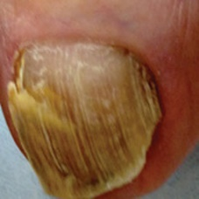 non-serious#1078 **Confidences:**normal = 1%; non-serious = 98%; warrants second opinion = 0%;   
The nail's condition is non-serious with confidence score of 98%.  
Otherwise it is normal with confidence score of 1%.×

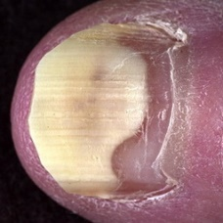 non-serious#1363 **Confidences:**normal = 0%; non-serious = 98%; warrants second opinion = 2%;   
The nail's condition is non-serious with confidence score of 98%.  
The confidence score for it warranting a second opinion is 2%.×

 non-serious#518 **Confidences:**normal = 2%; non-serious = 98%; warrants second opinion = 0%;   
The nail's condition is non-serious with confidence score of 98%.  
Otherwise it is normal with confidence score of 2%.×

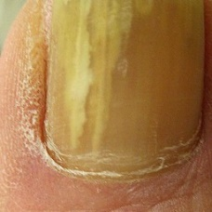 non-serious#1358 **Confidences:**normal = 0%; non-serious = 98%; warrants second opinion = 1%;   
The nail's condition is non-serious with confidence score of 98%.  
The confidence score for it warranting a second opinion is 1%.×

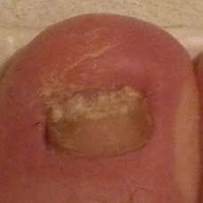 non-serious#1008 **Confidences:**normal = 1%; non-serious = 99%; warrants second opinion = 0%;   
The nail's condition is non-serious with confidence score of 99%.  
Otherwise it is normal with confidence score of 1%.×

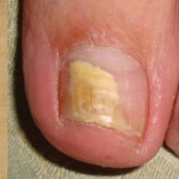 non-serious#1433 **Confidences:**normal = 1%; non-serious = 99%; warrants second opinion = 0%;   
The nail's condition is non-serious with confidence score of 99%.  
Otherwise it is normal with confidence score of 1%.×

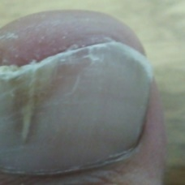 non-serious#1538 **Confidences:**normal = 1%; non-serious = 99%; warrants second opinion = 0%;   
The nail's condition is non-serious with confidence score of 99%.  
Otherwise it is normal with confidence score of 1%.×

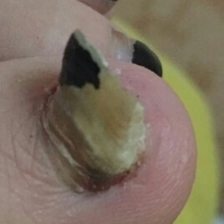 non-serious#1578 **Confidences:**normal = 1%; non-serious = 99%; warrants second opinion = 0%;   
The nail's condition is non-serious with confidence score of 99%.  
Otherwise it is normal with confidence score of 1%.×

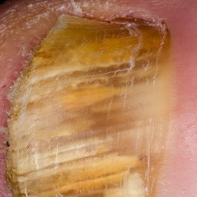 non-serious#1088 **Confidences:**normal = 0%; non-serious = 99%; warrants second opinion = 1%;   
The nail's condition is non-serious with confidence score of 99%.  
The confidence score for it warranting a second opinion is 1%.×

 non-serious#1318 **Confidences:**normal = 0%; non-serious = 99%; warrants second opinion = 1%;   
The nail's condition is non-serious with confidence score of 99%.  
The confidence score for it warranting a second opinion is 1%.×

 non-serious#473 **Confidences:**normal = 0%; non-serious = 99%; warrants second opinion = 1%;   
The nail's condition is non-serious with confidence score of 99%.  
The confidence score for it warranting a second opinion is 1%.×

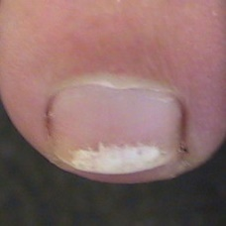 non-serious#1093 **Confidences:**normal = 1%; non-serious = 99%; warrants second opinion = 0%;   
The nail's condition is non-serious with confidence score of 99%.  
Otherwise it is normal with confidence score of 1%.×

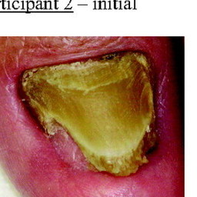 non-serious#1223 **Confidences:**normal = 0%; non-serious = 99%; warrants second opinion = 1%;   
The nail's condition is non-serious with confidence score of 99%.  
The confidence score for it warranting a second opinion is 1%.×

 non-serious#493 **Confidences:**normal = 1%; non-serious = 99%; warrants second opinion = 0%;   
The nail's condition is non-serious with confidence score of 99%.  
Otherwise it is normal with confidence score of 1%.×

 non-serious#968 **Confidences:**normal = 1%; non-serious = 99%; warrants second opinion = 0%;   
The nail's condition is non-serious with confidence score of 99%.  
Otherwise it is normal with confidence score of 1%.×

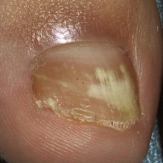 non-serious#1083 **Confidences:**normal = 1%; non-serious = 99%; warrants second opinion = 0%;   
The nail's condition is non-serious with confidence score of 99%.  
Otherwise it is normal with confidence score of 1%.×

 non-serious#393 **Confidences:**normal = 0%; non-serious = 99%; warrants second opinion = 1%;   
The nail's condition is non-serious with confidence score of 99%.  
The confidence score for it warranting a second opinion is 1%.×

 non-serious#743 **Confidences:**normal = 1%; non-serious = 99%; warrants second opinion = 0%;   
The nail's condition is non-serious with confidence score of 99%.  
Otherwise it is normal with confidence score of 1%.×

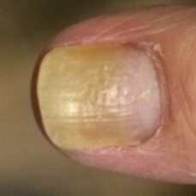 non-serious#1373 **Confidences:**normal = 1%; non-serious = 99%; warrants second opinion = 0%;   
The nail's condition is non-serious with confidence score of 99%.  
Otherwise it is normal with confidence score of 1%.×

 non-serious#543 **Confidences:**normal = 0%; non-serious = 99%; warrants second opinion = 1%;   
The nail's condition is non-serious with confidence score of 99%.  
The confidence score for it warranting a second opinion is 1%.×

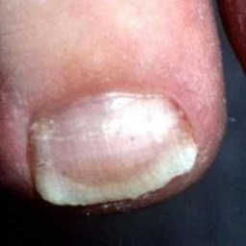 non-serious#1153 **Confidences:**normal = 1%; non-serious = 99%; warrants second opinion = 0%;   
The nail's condition is non-serious with confidence score of 99%.  
Otherwise it is normal with confidence score of 1%.×

 non-serious#653 **Confidences:**normal = 0%; non-serious = 99%; warrants second opinion = 1%;   
The nail's condition is non-serious with confidence score of 99%.  
The confidence score for it warranting a second opinion is 1%.×

 non-serious#528 **Confidences:**normal = 0%; non-serious = 99%; warrants second opinion = 1%;   
The nail's condition is non-serious with confidence score of 99%.  
The confidence score for it warranting a second opinion is 1%.×

 non-serious#313 **Confidences:**normal = 0%; non-serious = 99%; warrants second opinion = 1%;   
The nail's condition is non-serious with confidence score of 99%.  
The confidence score for it warranting a second opinion is 1%.×

 non-serious#443 **Confidences:**normal = 1%; non-serious = 99%; warrants second opinion = 0%;   
The nail's condition is non-serious with confidence score of 99%.  
Otherwise it is normal with confidence score of 1%.×

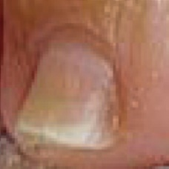 non-serious#1128 **Confidences:**normal = 1%; non-serious = 99%; warrants second opinion = 0%;   
The nail's condition is non-serious with confidence score of 99%.  
Otherwise it is normal with confidence score of 1%.×

 non-serious#978 **Confidences:**normal = 0%; non-serious = 99%; warrants second opinion = 1%;   
The nail's condition is non-serious with confidence score of 99%.  
The confidence score for it warranting a second opinion is 1%.×

 non-serious#723 **Confidences:**normal = 0%; non-serious = 99%; warrants second opinion = 1%;   
The nail's condition is non-serious with confidence score of 99%.  
The confidence score for it warranting a second opinion is 1%.×

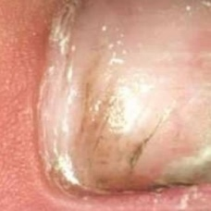 non-serious#1418 **Confidences:**normal = 0%; non-serious = 99%; warrants second opinion = 1%;   
The nail's condition is non-serious with confidence score of 99%.  
The confidence score for it warranting a second opinion is 1%.×

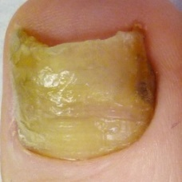 non-serious#1403 **Confidences:**normal = 0%; non-serious = 99%; warrants second opinion = 0%;   
The nail's condition is non-serious with confidence score of 99%.×

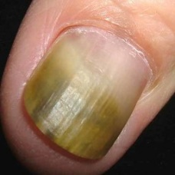 non-serious#1048 **Confidences:**normal = 0%; non-serious = 99%; warrants second opinion = 1%;   
The nail's condition is non-serious with confidence score of 99%.  
The confidence score for it warranting a second opinion is 1%.×

 non-serious#1278 **Confidences:**normal = 0%; non-serious = 99%; warrants second opinion = 1%;   
The nail's condition is non-serious with confidence score of 99%.  
The confidence score for it warranting a second opinion is 1%.×

 non-serious#28 **Confidences:**normal = 0%; non-serious = 99%; warrants second opinion = 1%;   
The nail's condition is non-serious with confidence score of 99%.  
The confidence score for it warranting a second opinion is 1%.×

 non-serious#413 **Confidences:**normal = 0%; non-serious = 99%; warrants second opinion = 1%;   
The nail's condition is non-serious with confidence score of 99%.  
The confidence score for it warranting a second opinion is 1%.×

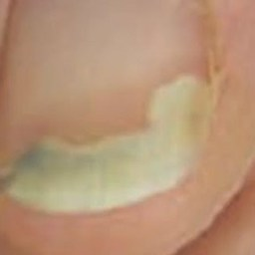 non-serious#1598 **Confidences:**normal = 0%; non-serious = 99%; warrants second opinion = 0%;   
The nail's condition is non-serious with confidence score of 99%.×

 non-serious#228 **Confidences:**normal = 1%; non-serious = 99%; warrants second opinion = 0%;   
The nail's condition is non-serious with confidence score of 99%.  
Otherwise it is normal with confidence score of 1%.×

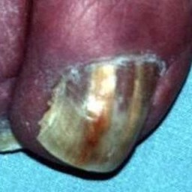 non-serious#1408 **Confidences:**normal = 0%; non-serious = 99%; warrants second opinion = 1%;   
The nail's condition is non-serious with confidence score of 99%.  
The confidence score for it warranting a second opinion is 1%.×

 non-serious#553 **Confidences:**normal = 0%; non-serious = 99%; warrants second opinion = 1%;   
The nail's condition is non-serious with confidence score of 99%.  
The confidence score for it warranting a second opinion is 1%.×

 non-serious#618 **Confidences:**normal = 0%; non-serious = 99%; warrants second opinion = 1%;   
The nail's condition is non-serious with confidence score of 99%.  
The confidence score for it warranting a second opinion is 1%.×

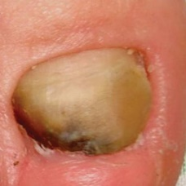 non-serious#1423 **Confidences:**normal = 0%; non-serious = 100%; warrants second opinion = 0%;   
The nail's condition is non-serious with confidence score of 100%.×

 non-serious#568 **Confidences:**normal = 0%; non-serious = 100%; warrants second opinion = 0%;   
The nail's condition is non-serious with confidence score of 100%.×

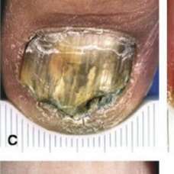 non-serious#1038 **Confidences:**normal = 0%; non-serious = 100%; warrants second opinion = 0%;   
The nail's condition is non-serious with confidence score of 100%.×

 non-serious#638 **Confidences:**normal = 0%; non-serious = 100%; warrants second opinion = 0%;   
The nail's condition is non-serious with confidence score of 100%.×

 non-serious#683 **Confidences:**normal = 0%; non-serious = 100%; warrants second opinion = 0%;   
The nail's condition is non-serious with confidence score of 100%.×

 non-serious#498 **Confidences:**normal = 0%; non-serious = 100%; warrants second opinion = 0%;   
The nail's condition is non-serious with confidence score of 100%.×

 non-serious#868 **Confidences:**normal = 0%; non-serious = 100%; warrants second opinion = 0%;   
The nail's condition is non-serious with confidence score of 100%.×

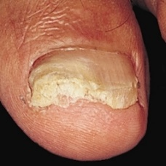 non-serious#1148 **Confidences:**normal = 0%; non-serious = 100%; warrants second opinion = 0%;   
The nail's condition is non-serious with confidence score of 100%.×

 non-serious#3 **Confidences:**normal = 0%; non-serious = 100%; warrants second opinion = 0%;   
The nail's condition is non-serious with confidence score of 100%.×

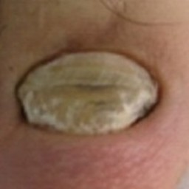 non-serious#1353 **Confidences:**normal = 0%; non-serious = 100%; warrants second opinion = 0%;   
The nail's condition is non-serious with confidence score of 100%.×

 non-serious#523 **Confidences:**normal = 0%; non-serious = 100%; warrants second opinion = 0%;   
The nail's condition is non-serious with confidence score of 100%.×

 non-serious#33 **Confidences:**normal = 0%; non-serious = 100%; warrants second opinion = 0%;   
The nail's condition is non-serious with confidence score of 100%.×

 non-serious#43 **Confidences:**normal = 0%; non-serious = 100%; warrants second opinion = 0%;   
The nail's condition is non-serious with confidence score of 100%.×

 non-serious#458 **Confidences:**normal = 0%; non-serious = 100%; warrants second opinion = 0%;   
The nail's condition is non-serious with confidence score of 100%.×

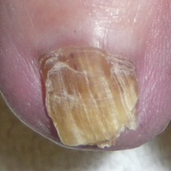 non-serious#1263 **Confidences:**normal = 0%; non-serious = 100%; warrants second opinion = 0%;   
The nail's condition is non-serious with confidence score of 100%.×

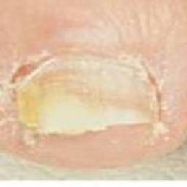 non-serious#1208 **Confidences:**normal = 0%; non-serious = 100%; warrants second opinion = 0%;   
The nail's condition is non-serious with confidence score of 100%.×

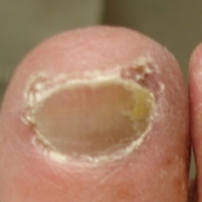 non-serious#1548 **Confidences:**normal = 0%; non-serious = 100%; warrants second opinion = 0%;   
The nail's condition is non-serious with confidence score of 100%.×

 non-serious#1563 **Confidences:**normal = 0%; non-serious = 100%; warrants second opinion = 0%;   
The nail's condition is non-serious with confidence score of 100%.×

 non-serious#23 **Confidences:**normal = 0%; non-serious = 100%; warrants second opinion = 0%;   
The nail's condition is non-serious with confidence score of 100%.×

 non-serious#328 **Confidences:**normal = 0%; non-serious = 100%; warrants second opinion = 0%;   
The nail's condition is non-serious with confidence score of 100%.×

 non-serious#78 **Confidences:**normal = 0%; non-serious = 100%; warrants second opinion = 0%;   
The nail's condition is non-serious with confidence score of 100%.×

 non-serious#118 **Confidences:**normal = 0%; non-serious = 100%; warrants second opinion = 0%;   
The nail's condition is non-serious with confidence score of 100%.×

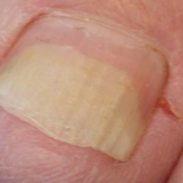 non-serious#1428 **Confidences:**normal = 0%; non-serious = 100%; warrants second opinion = 0%;   
The nail's condition is non-serious with confidence score of 100%.×

 non-serious#938 **Confidences:**normal = 0%; non-serious = 100%; warrants second opinion = 0%;   
The nail's condition is non-serious with confidence score of 100%.×

 non-serious#173 **Confidences:**normal = 0%; non-serious = 100%; warrants second opinion = 0%;   
The nail's condition is non-serious with confidence score of 100%.×

 non-serious#448 **Confidences:**normal = 0%; non-serious = 100%; warrants second opinion = 0%;   
The nail's condition is non-serious with confidence score of 100%.×

 non-serious#948 **Confidences:**normal = 0%; non-serious = 100%; warrants second opinion = 0%;   
The nail's condition is non-serious with confidence score of 100%.×

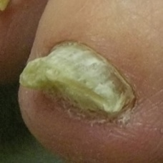 non-serious#1328 **Confidences:**normal = 0%; non-serious = 100%; warrants second opinion = 0%;   
The nail's condition is non-serious with confidence score of 100%.×

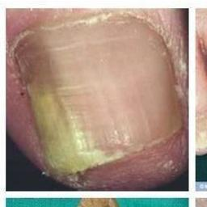 non-serious#1198 **Confidences:**normal = 0%; non-serious = 100%; warrants second opinion = 0%;   
The nail's condition is non-serious with confidence score of 100%.×

 non-serious#258 **Confidences:**normal = 0%; non-serious = 100%; warrants second opinion = 0%;   
The nail's condition is non-serious with confidence score of 100%.×

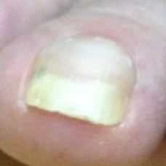 non-serious#1453 **Confidences:**normal = 0%; non-serious = 100%; warrants second opinion = 0%;   
The nail's condition is non-serious with confidence score of 100%.×

 non-serious#223 **Confidences:**normal = 0%; non-serious = 100%; warrants second opinion = 0%;   
The nail's condition is non-serious with confidence score of 100%.×

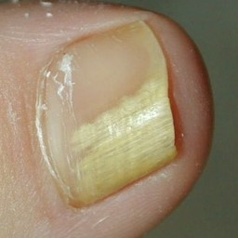 non-serious#1188 **Confidences:**normal = 0%; non-serious = 100%; warrants second opinion = 0%;   
The nail's condition is non-serious with confidence score of 100%.×

 non-serious#123 **Confidences:**normal = 0%; non-serious = 100%; warrants second opinion = 0%;   
The nail's condition is non-serious with confidence score of 100%.×

 non-serious#533 **Confidences:**normal = 0%; non-serious = 100%; warrants second opinion = 0%;   
The nail's condition is non-serious with confidence score of 100%.×

 non-serious#238 **Confidences:**normal = 0%; non-serious = 100%; warrants second opinion = 0%;   
The nail's condition is non-serious with confidence score of 100%.×

 non-serious#343 **Confidences:**normal = 0%; non-serious = 100%; warrants second opinion = 0%;   
The nail's condition is non-serious with confidence score of 100%.×

 non-serious#338 **Confidences:**normal = 0%; non-serious = 100%; warrants second opinion = 0%;   
The nail's condition is non-serious with confidence score of 100%.×

 non-serious#748 **Confidences:**normal = 0%; non-serious = 100%; warrants second opinion = 0%;   
The nail's condition is non-serious with confidence score of 100%.×

 non-serious#333 **Confidences:**normal = 0%; non-serious = 100%; warrants second opinion = 0%;   
The nail's condition is non-serious with confidence score of 100%.×

 non-serious#308 **Confidences:**normal = 0%; non-serious = 100%; warrants second opinion = 0%;   
The nail's condition is non-serious with confidence score of 100%.×

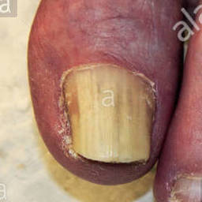 non-serious#1238 **Confidences:**normal = 0%; non-serious = 100%; warrants second opinion = 0%;   
The nail's condition is non-serious with confidence score of 100%.×

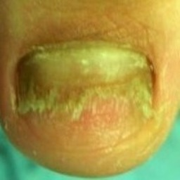 non-serious#1568 **Confidences:**normal = 0%; non-serious = 100%; warrants second opinion = 0%;   
The nail's condition is non-serious with confidence score of 100%.×

 non-serious#218 **Confidences:**normal = 0%; non-serious = 100%; warrants second opinion = 0%;   
The nail's condition is non-serious with confidence score of 100%.×

 non-serious#673 **Confidences:**normal = 0%; non-serious = 100%; warrants second opinion = 0%;   
The nail's condition is non-serious with confidence score of 100%.×

 non-serious#368 **Confidences:**normal = 0%; non-serious = 100%; warrants second opinion = 0%;   
The nail's condition is non-serious with confidence score of 100%.×

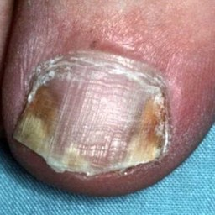 non-serious#1273 **Confidences:**normal = 0%; non-serious = 100%; warrants second opinion = 0%;   
The nail's condition is non-serious with confidence score of 100%.×

 non-serious#143 **Confidences:**normal = 0%; non-serious = 100%; warrants second opinion = 0%;   
The nail's condition is non-serious with confidence score of 100%.×

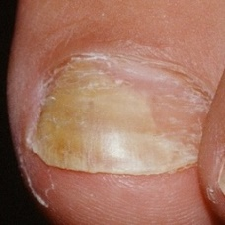 non-serious#1283 **Confidences:**normal = 0%; non-serious = 100%; warrants second opinion = 0%;   
The nail's condition is non-serious with confidence score of 100%.×

 non-serious#838 **Confidences:**normal = 0%; non-serious = 100%; warrants second opinion = 0%;   
The nail's condition is non-serious with confidence score of 100%.×

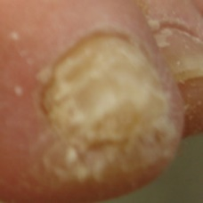 non-serious#1588 **Confidences:**normal = 0%; non-serious = 100%; warrants second opinion = 0%;   
The nail's condition is non-serious with confidence score of 100%.×

 non-serious#538 **Confidences:**normal = 0%; non-serious = 100%; warrants second opinion = 0%;   
The nail's condition is non-serious with confidence score of 100%.×

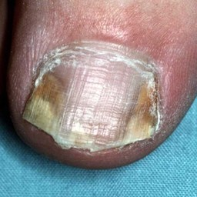 non-serious#1368 **Confidences:**normal = 0%; non-serious = 100%; warrants second opinion = 0%;   
The nail's condition is non-serious with confidence score of 100%.×

 non-serious#13 **Confidences:**normal = 0%; non-serious = 100%; warrants second opinion = 0%;   
The nail's condition is non-serious with confidence score of 100%.×

 non-serious#18 **Confidences:**normal = 0%; non-serious = 100%; warrants second opinion = 0%;   
The nail's condition is non-serious with confidence score of 100%.×

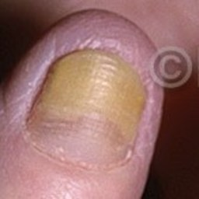 non-serious#1243 **Confidences:**normal = 0%; non-serious = 100%; warrants second opinion = 0%;   
The nail's condition is non-serious with confidence score of 100%.×

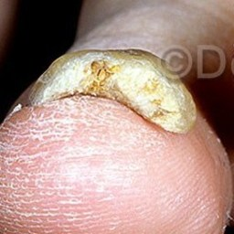 non-serious#1138 **Confidences:**normal = 0%; non-serious = 100%; warrants second opinion = 0%;   
The nail's condition is non-serious with confidence score of 100%.×

 non-serious#893 **Confidences:**normal = 0%; non-serious = 100%; warrants second opinion = 0%;   
The nail's condition is non-serious with confidence score of 100%.×

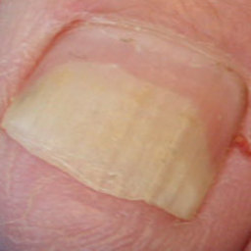 non-serious#1033 **Confidences:**normal = 0%; non-serious = 100%; warrants second opinion = 0%;   
The nail's condition is non-serious with confidence score of 100%.×

 non-serious#1233 **Confidences:**normal = 0%; non-serious = 100%; warrants second opinion = 0%;   
The nail's condition is non-serious with confidence score of 100%.×

 non-serious#1288 **Confidences:**normal = 0%; non-serious = 100%; warrants second opinion = 0%;   
The nail's condition is non-serious with confidence score of 100%.×

 non-serious#133 **Confidences:**normal = 0%; non-serious = 100%; warrants second opinion = 0%;   
The nail's condition is non-serious with confidence score of 100%.×

 non-serious#658 **Confidences:**normal = 0%; non-serious = 100%; warrants second opinion = 0%;   
The nail's condition is non-serious with confidence score of 100%.×

 non-serious#898 **Confidences:**normal = 0%; non-serious = 100%; warrants second opinion = 0%;   
The nail's condition is non-serious with confidence score of 100%.×

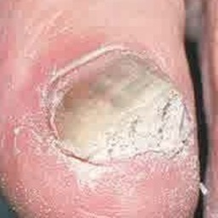 non-serious#1073 **Confidences:**normal = 0%; non-serious = 100%; warrants second opinion = 0%;   
The nail's condition is non-serious with confidence score of 100%.×

 non-serious#863 **Confidences:**normal = 0%; non-serious = 100%; warrants second opinion = 0%;   
The nail's condition is non-serious with confidence score of 100%.×

 non-serious#8 **Confidences:**normal = 0%; non-serious = 100%; warrants second opinion = 0%;   
The nail's condition is non-serious with confidence score of 100%.×

 non-serious#278 **Confidences:**normal = 0%; non-serious = 100%; warrants second opinion = 0%;   
The nail's condition is non-serious with confidence score of 100%.×

 non-serious#998 **Confidences:**normal = 0%; non-serious = 100%; warrants second opinion = 0%;   
The nail's condition is non-serious with confidence score of 100%.×

 non-serious#178 **Confidences:**normal = 0%; non-serious = 100%; warrants second opinion = 0%;   
The nail's condition is non-serious with confidence score of 100%.×

 non-serious#63 **Confidences:**normal = 0%; non-serious = 100%; warrants second opinion = 0%;   
The nail's condition is non-serious with confidence score of 100%.×

 non-serious#168 **Confidences:**normal = 0%; non-serious = 100%; warrants second opinion = 0%;   
The nail's condition is non-serious with confidence score of 100%.×

 non-serious#763 **Confidences:**normal = 0%; non-serious = 100%; warrants second opinion = 0%;   
The nail's condition is non-serious with confidence score of 100%.×

 non-serious#288 **Confidences:**normal = 0%; non-serious = 100%; warrants second opinion = 0%;   
The nail's condition is non-serious with confidence score of 100%.×

 non-serious#478 **Confidences:**normal = 0%; non-serious = 100%; warrants second opinion = 0%;   
The nail's condition is non-serious with confidence score of 100%.×

 non-serious#358 **Confidences:**normal = 0%; non-serious = 100%; warrants second opinion = 0%;   
The nail's condition is non-serious with confidence score of 100%.×

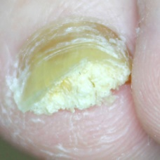 non-serious#1158 **Confidences:**normal = 0%; non-serious = 100%; warrants second opinion = 0%;   
The nail's condition is non-serious with confidence score of 100%.×

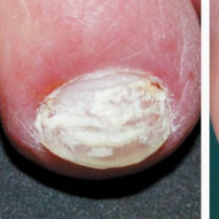 non-serious#1608 **Confidences:**normal = 0%; non-serious = 100%; warrants second opinion = 0%;   
The nail's condition is non-serious with confidence score of 100%.×

 non-serious#88 **Confidences:**normal = 0%; non-serious = 100%; warrants second opinion = 0%;   
The nail's condition is non-serious with confidence score of 100%.×

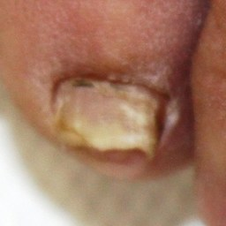 non-serious#1378 **Confidences:**normal = 0%; non-serious = 100%; warrants second opinion = 0%;   
The nail's condition is non-serious with confidence score of 100%.×

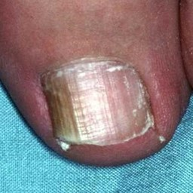 non-serious#1393 **Confidences:**normal = 0%; non-serious = 100%; warrants second opinion = 0%;   
The nail's condition is non-serious with confidence score of 100%.×

 non-serious#213 **Confidences:**normal = 0%; non-serious = 100%; warrants second opinion = 0%;   
The nail's condition is non-serious with confidence score of 100%.×

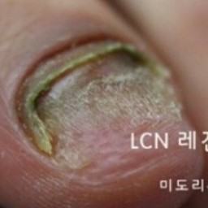 non-serious#1583 **Confidences:**normal = 0%; non-serious = 100%; warrants second opinion = 0%;   
The nail's condition is non-serious with confidence score of 100%.×

 non-serious#138 **Confidences:**normal = 0%; non-serious = 100%; warrants second opinion = 0%;   
The nail's condition is non-serious with confidence score of 100%.×

 non-serious#983 **Confidences:**normal = 0%; non-serious = 100%; warrants second opinion = 0%;   
The nail's condition is non-serious with confidence score of 100%.×

 non-serious#283 **Confidences:**normal = 0%; non-serious = 100%; warrants second opinion = 0%;   
The nail's condition is non-serious with confidence score of 100%.×

 non-serious#243 **Confidences:**normal = 0%; non-serious = 100%; warrants second opinion = 0%;   
The nail's condition is non-serious with confidence score of 100%.×

 non-serious#183 **Confidences:**normal = 0%; non-serious = 100%; warrants second opinion = 0%;   
The nail's condition is non-serious with confidence score of 100%.×

 non-serious#203 **Confidences:**normal = 0%; non-serious = 100%; warrants second opinion = 0%;   
The nail's condition is non-serious with confidence score of 100%.×

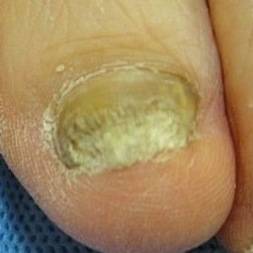 non-serious#1573 **Confidences:**normal = 0%; non-serious = 100%; warrants second opinion = 0%;   
The nail's condition is non-serious with confidence score of 100%.×

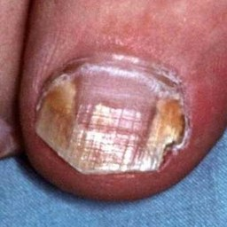 non-serious#1343 **Confidences:**normal = 0%; non-serious = 100%; warrants second opinion = 0%;   
The nail's condition is non-serious with confidence score of 100%.×

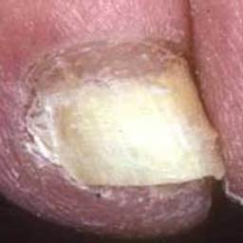 non-serious#1448 **Confidences:**normal = 0%; non-serious = 100%; warrants second opinion = 0%;   
The nail's condition is non-serious with confidence score of 100%.×

 non-serious#928 **Confidences:**normal = 0%; non-serious = 100%; warrants second opinion = 0%;   
The nail's condition is non-serious with confidence score of 100%.×

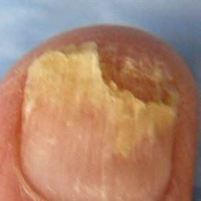 non-serious#1133 **Confidences:**normal = 0%; non-serious = 100%; warrants second opinion = 0%;   
The nail's condition is non-serious with confidence score of 100%.×

 non-serious#108 **Confidences:**normal = 0%; non-serious = 100%; warrants second opinion = 0%;   
The nail's condition is non-serious with confidence score of 100%.×

 non-serious#593 **Confidences:**normal = 0%; non-serious = 100%; warrants second opinion = 0%;   
The nail's condition is non-serious with confidence score of 100%.×

 non-serious#263 **Confidences:**normal = 0%; non-serious = 100%; warrants second opinion = 0%;   
The nail's condition is non-serious with confidence score of 100%.×

 non-serious#83 **Confidences:**normal = 0%; non-serious = 100%; warrants second opinion = 0%;   
The nail's condition is non-serious with confidence score of 100%.×

 non-serious#273 **Confidences:**normal = 0%; non-serious = 100%; warrants second opinion = 0%;   
The nail's condition is non-serious with confidence score of 100%.×

 non-serious#688 **Confidences:**normal = 0%; non-serious = 100%; warrants second opinion = 0%;   
The nail's condition is non-serious with confidence score of 100%.×

 non-serious#818 **Confidences:**normal = 0%; non-serious = 100%; warrants second opinion = 0%;   
The nail's condition is non-serious with confidence score of 100%.×

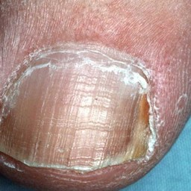 non-serious#1398 **Confidences:**normal = 0%; non-serious = 100%; warrants second opinion = 0%;   
The nail's condition is non-serious with confidence score of 100%.×

 non-serious#468 **Confidences:**normal = 0%; non-serious = 100%; warrants second opinion = 0%;   
The nail's condition is non-serious with confidence score of 100%.×

 non-serious#943 **Confidences:**normal = 0%; non-serious = 100%; warrants second opinion = 0%;   
The nail's condition is non-serious with confidence score of 100%.×

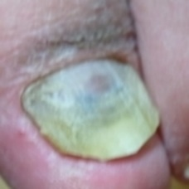 non-serious#1513 **Confidences:**normal = 0%; non-serious = 100%; warrants second opinion = 0%;   
The nail's condition is non-serious with confidence score of 100%.×

 non-serious#318 **Confidences:**normal = 0%; non-serious = 100%; warrants second opinion = 0%;   
The nail's condition is non-serious with confidence score of 100%.×

 non-serious#483 **Confidences:**normal = 0%; non-serious = 100%; warrants second opinion = 0%;   
The nail's condition is non-serious with confidence score of 100%.×

 non-serious#788 **Confidences:**normal = 0%; non-serious = 100%; warrants second opinion = 0%;   
The nail's condition is non-serious with confidence score of 100%.×

 non-serious#823 **Confidences:**normal = 0%; non-serious = 100%; warrants second opinion = 0%;   
The nail's condition is non-serious with confidence score of 100%.×

 non-serious#908 **Confidences:**normal = 0%; non-serious = 100%; warrants second opinion = 0%;   
The nail's condition is non-serious with confidence score of 100%.×

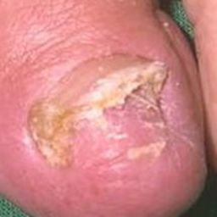 non-serious#1118 **Confidences:**normal = 0%; non-serious = 100%; warrants second opinion = 0%;   
The nail's condition is non-serious with confidence score of 100%.×

 non-serious#578 **Confidences:**normal = 0%; non-serious = 100%; warrants second opinion = 0%;   
The nail's condition is non-serious with confidence score of 100%.×

 non-serious#663 **Confidences:**normal = 0%; non-serious = 100%; warrants second opinion = 0%;   
The nail's condition is non-serious with confidence score of 100%.×

 non-serious#718 **Confidences:**normal = 0%; non-serious = 100%; warrants second opinion = 0%;   
The nail's condition is non-serious with confidence score of 100%.×

 non-serious#758 **Confidences:**normal = 0%; non-serious = 100%; warrants second opinion = 0%;   
The nail's condition is non-serious with confidence score of 100%.×

 non-serious#733 **Confidences:**normal = 0%; non-serious = 100%; warrants second opinion = 0%;   
The nail's condition is non-serious with confidence score of 100%.×

 non-serious#858 **Confidences:**normal = 0%; non-serious = 100%; warrants second opinion = 0%;   
The nail's condition is non-serious with confidence score of 100%.×

 non-serious#848 **Confidences:**normal = 0%; non-serious = 100%; warrants second opinion = 0%;   
The nail's condition is non-serious with confidence score of 100%.×

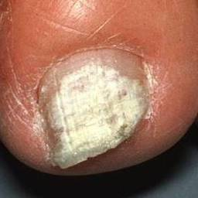 non-serious#1463 **Confidences:**normal = 0%; non-serious = 100%; warrants second opinion = 0%;   
The nail's condition is non-serious with confidence score of 100%.×

 non-serious#728 **Confidences:**normal = 0%; non-serious = 100%; warrants second opinion = 0%;   
The nail's condition is non-serious with confidence score of 100%.×

 non-serious#488 **Confidences:**normal = 0%; non-serious = 100%; warrants second opinion = 0%;   
The nail's condition is non-serious with confidence score of 100%.×

 non-serious#808 **Confidences:**normal = 0%; non-serious = 100%; warrants second opinion = 0%;   
The nail's condition is non-serious with confidence score of 100%.×

 non-serious#873 **Confidences:**normal = 0%; non-serious = 100%; warrants second opinion = 0%;   
The nail's condition is non-serious with confidence score of 100%.×

 non-serious#453 **Confidences:**normal = 0%; non-serious = 100%; warrants second opinion = 0%;   
The nail's condition is non-serious with confidence score of 100%.×

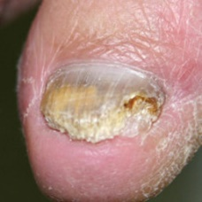 non-serious#1488 **Confidences:**normal = 0%; non-serious = 100%; warrants second opinion = 0%;   
The nail's condition is non-serious with confidence score of 100%.×

 non-serious#1503 **Confidences:**normal = 0%; non-serious = 100%; warrants second opinion = 0%;   
The nail's condition is non-serious with confidence score of 100%.×

 non-serious#158 **Confidences:**normal = 0%; non-serious = 100%; warrants second opinion = 0%;   
The nail's condition is non-serious with confidence score of 100%.×

 non-serious#53 **Confidences:**normal = 0%; non-serious = 100%; warrants second opinion = 0%;   
The nail's condition is non-serious with confidence score of 100%.×

 non-serious#643 **Confidences:**normal = 0%; non-serious = 100%; warrants second opinion = 0%;   
The nail's condition is non-serious with confidence score of 100%.×

 non-serious#783 **Confidences:**normal = 0%; non-serious = 100%; warrants second opinion = 0%;   
The nail's condition is non-serious with confidence score of 100%.×

 non-serious#803 **Confidences:**normal = 0%; non-serious = 100%; warrants second opinion = 0%;   
The nail's condition is non-serious with confidence score of 100%.×

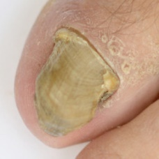 non-serious#1163 **Confidences:**normal = 0%; non-serious = 100%; warrants second opinion = 0%;   
The nail's condition is non-serious with confidence score of 100%.×

 non-serious#933 **Confidences:**normal = 0%; non-serious = 100%; warrants second opinion = 0%;   
The nail's condition is non-serious with confidence score of 100%.×

 non-serious#958 **Confidences:**normal = 0%; non-serious = 100%; warrants second opinion = 0%;   
The nail's condition is non-serious with confidence score of 100%.×

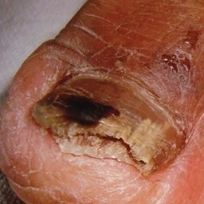 non-serious#1213 **Confidences:**normal = 0%; non-serious = 100%; warrants second opinion = 0%;   
The nail's condition is non-serious with confidence score of 100%.×

 non-serious#433 **Confidences:**normal = 0%; non-serious = 100%; warrants second opinion = 0%;   
The nail's condition is non-serious with confidence score of 100%.×

 non-serious#563 **Confidences:**normal = 0%; non-serious = 100%; warrants second opinion = 0%;   
The nail's condition is non-serious with confidence score of 100%.×

 non-serious#713 **Confidences:**normal = 0%; non-serious = 100%; warrants second opinion = 0%;   
The nail's condition is non-serious with confidence score of 100%.×

 non-serious#753 **Confidences:**normal = 0%; non-serious = 100%; warrants second opinion = 0%;   
The nail's condition is non-serious with confidence score of 100%.×

 non-serious#773 **Confidences:**normal = 0%; non-serious = 100%; warrants second opinion = 0%;   
The nail's condition is non-serious with confidence score of 100%.×

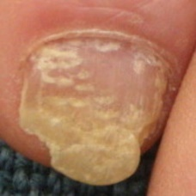 non-serious#1258 **Confidences:**normal = 0%; non-serious = 100%; warrants second opinion = 0%;   
The nail's condition is non-serious with confidence score of 100%.×

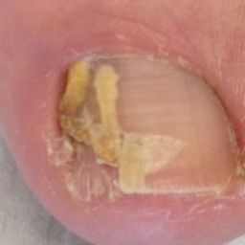 non-serious#1098 **Confidences:**normal = 0%; non-serious = 100%; warrants second opinion = 0%;   
The nail's condition is non-serious with confidence score of 100%.×

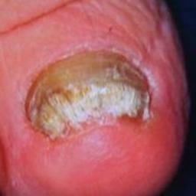 non-serious#1493 **Confidences:**normal = 0%; non-serious = 100%; warrants second opinion = 0%;   
The nail's condition is non-serious with confidence score of 100%.×

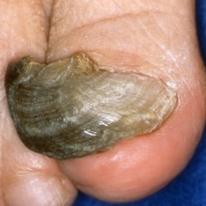 non-serious#1498 **Confidences:**normal = 0%; non-serious = 100%; warrants second opinion = 0%;   
The nail's condition is non-serious with confidence score of 100%.×

 non-serious#1508 **Confidences:**normal = 0%; non-serious = 100%; warrants second opinion = 0%;   
The nail's condition is non-serious with confidence score of 100%.×

 non-serious#378 **Confidences:**normal = 0%; non-serious = 100%; warrants second opinion = 0%;   
The nail's condition is non-serious with confidence score of 100%.×

 non-serious#768 **Confidences:**normal = 0%; non-serious = 100%; warrants second opinion = 0%;   
The nail's condition is non-serious with confidence score of 100%.×

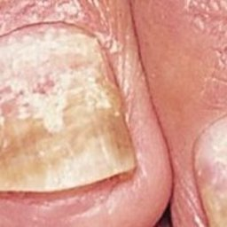 non-serious#1023 **Confidences:**normal = 0%; non-serious = 100%; warrants second opinion = 0%;   
The nail's condition is non-serious with confidence score of 100%.×

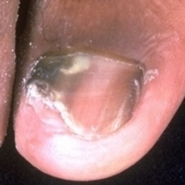 non-serious#1443 **Confidences:**normal = 0%; non-serious = 100%; warrants second opinion = 0%;   
The nail's condition is non-serious with confidence score of 100%.×

 non-serious#923 **Confidences:**normal = 0%; non-serious = 100%; warrants second opinion = 0%;   
The nail's condition is non-serious with confidence score of 100%.×

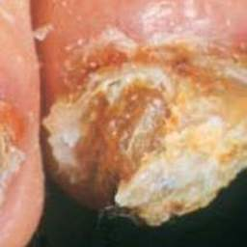 non-serious#1063 **Confidences:**normal = 0%; non-serious = 100%; warrants second opinion = 0%;   
The nail's condition is non-serious with confidence score of 100%.×

 non-serious#623 **Confidences:**normal = 0%; non-serious = 100%; warrants second opinion = 0%;   
The nail's condition is non-serious with confidence score of 100%.×

 non-serious#793 **Confidences:**normal = 0%; non-serious = 100%; warrants second opinion = 0%;   
The nail's condition is non-serious with confidence score of 100%.×

 non-serious#973 **Confidences:**normal = 0%; non-serious = 100%; warrants second opinion = 0%;   
The nail's condition is non-serious with confidence score of 100%.×

 non-serious#233 **Confidences:**normal = 0%; non-serious = 100%; warrants second opinion = 0%;   
The nail's condition is non-serious with confidence score of 100%.×

 non-serious#883 **Confidences:**normal = 0%; non-serious = 100%; warrants second opinion = 0%;   
The nail's condition is non-serious with confidence score of 100%.×

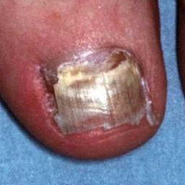 non-serious#1193 **Confidences:**normal = 0%; non-serious = 100%; warrants second opinion = 0%;   
The nail's condition is non-serious with confidence score of 100%.×

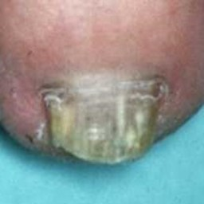 non-serious#1473 **Confidences:**normal = 0%; non-serious = 100%; warrants second opinion = 0%;   
The nail's condition is non-serious with confidence score of 100%.×

 non-serious#48 **Confidences:**normal = 0%; non-serious = 100%; warrants second opinion = 0%;   
The nail's condition is non-serious with confidence score of 100%.×

 non-serious#558 **Confidences:**normal = 0%; non-serious = 100%; warrants second opinion = 0%;   
The nail's condition is non-serious with confidence score of 100%.×

 non-serious#628 **Confidences:**normal = 0%; non-serious = 100%; warrants second opinion = 0%;   
The nail's condition is non-serious with confidence score of 100%.×

 non-serious#738 **Confidences:**normal = 0%; non-serious = 100%; warrants second opinion = 0%;   
The nail's condition is non-serious with confidence score of 100%.×

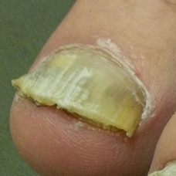 non-serious#1028 **Confidences:**normal = 0%; non-serious = 100%; warrants second opinion = 0%;   
The nail's condition is non-serious with confidence score of 100%.×

 non-serious#98 **Confidences:**normal = 0%; non-serious = 100%; warrants second opinion = 0%;   
The nail's condition is non-serious with confidence score of 100%.×

 non-serious#128 **Confidences:**normal = 0%; non-serious = 100%; warrants second opinion = 0%;   
The nail's condition is non-serious with confidence score of 100%.×

 non-serious#1003 **Confidences:**normal = 0%; non-serious = 100%; warrants second opinion = 0%;   
The nail's condition is non-serious with confidence score of 100%.×

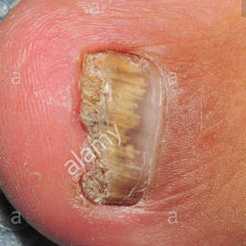 non-serious#1183 **Confidences:**normal = 0%; non-serious = 100%; warrants second opinion = 0%;   
The nail's condition is non-serious with confidence score of 100%.×

 non-serious#268 **Confidences:**normal = 0%; non-serious = 100%; warrants second opinion = 0%;   
The nail's condition is non-serious with confidence score of 100%.×

 non-serious#353 **Confidences:**normal = 0%; non-serious = 100%; warrants second opinion = 0%;   
The nail's condition is non-serious with confidence score of 100%.×

 non-serious#648 **Confidences:**normal = 0%; non-serious = 100%; warrants second opinion = 0%;   
The nail's condition is non-serious with confidence score of 100%.×

 non-serious#953 **Confidences:**normal = 0%; non-serious = 100%; warrants second opinion = 0%;   
The nail's condition is non-serious with confidence score of 100%.×

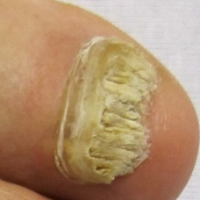 non-serious#1458 **Confidences:**normal = 0%; non-serious = 100%; warrants second opinion = 0%;   
The nail's condition is non-serious with confidence score of 100%.×

 non-serious#93 **Confidences:**normal = 0%; non-serious = 100%; warrants second opinion = 0%;   
The nail's condition is non-serious with confidence score of 100%.×

 non-serious#373 **Confidences:**normal = 0%; non-serious = 100%; warrants second opinion = 0%;   
The nail's condition is non-serious with confidence score of 100%.×

 non-serious#573 **Confidences:**normal = 0%; non-serious = 100%; warrants second opinion = 0%;   
The nail's condition is non-serious with confidence score of 100%.×

 non-serious#993 **Confidences:**normal = 0%; non-serious = 100%; warrants second opinion = 0%;   
The nail's condition is non-serious with confidence score of 100%.×

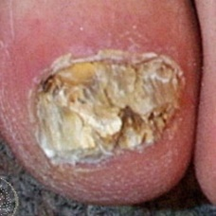 non-serious#1308 **Confidences:**normal = 0%; non-serious = 100%; warrants second opinion = 0%;   
The nail's condition is non-serious with confidence score of 100%.×

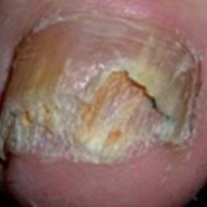 non-serious#1438 **Confidences:**normal = 0%; non-serious = 100%; warrants second opinion = 0%;   
The nail's condition is non-serious with confidence score of 100%.×

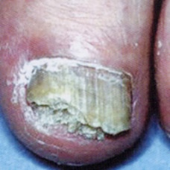 non-serious#1558 **Confidences:**normal = 0%; non-serious = 100%; warrants second opinion = 0%;   
The nail's condition is non-serious with confidence score of 100%.×

 warrants second opinion#414 **Confidences:**normal = 0%; non-serious = 100%; warrants second opinion = 0%;   
The nail's condition is non-serious with confidence score of 100%.×

 warrants second opinion#24 **Confidences:**normal = 0%; non-serious = 100%; warrants second opinion = 0%;   
The nail's condition is non-serious with confidence score of 100%.×

 warrants second opinion#59 **Confidences:**normal = 4%; non-serious = 96%; warrants second opinion = 0%;   
The nail's condition is non-serious with confidence score of 96%.  
Otherwise it is normal with confidence score of 4%.×

 warrants second opinion#4 **Confidences:**normal = 100%; non-serious = 0%; warrants second opinion = 0%;   
The nail's condition is normal with confidence score of 100%.×

 warrants second opinion#14 **Confidences:**normal = 99%; non-serious = 0%; warrants second opinion = 1%;   
The nail's condition is normal with confidence score of 99%.  
The confidence score for it warranting a second opinion is 1%.×

 warrants second opinion#459 **Confidences:**normal = 0%; non-serious = 99%; warrants second opinion = 1%;   
The nail's condition is non-serious with confidence score of 99%.  
The confidence score for it warranting a second opinion is 1%.×

 warrants second opinion#94 **Confidences:**normal = 0%; non-serious = 99%; warrants second opinion = 1%;   
The nail's condition is non-serious with confidence score of 99%.  
The confidence score for it warranting a second opinion is 1%.×

 warrants second opinion#479 **Confidences:**normal = 0%; non-serious = 98%; warrants second opinion = 2%;   
The nail's condition is non-serious with confidence score of 98%.  
The confidence score for it warranting a second opinion is 2%.×

 warrants second opinion#44 **Confidences:**normal = 28%; non-serious = 69%; warrants second opinion = 2%;   
The nail's condition is non-serious with confidence score of 69%.  
Otherwise it is normal with confidence score of 28%.×

 warrants second opinion#359 **Confidences:**normal = 97%; non-serious = 0%; warrants second opinion = 3%;   
The nail's condition is normal with confidence score of 97%.  
The confidence score for it warranting a second opinion is 3%.×

 warrants second opinion#449 **Confidences:**normal = 3%; non-serious = 94%; warrants second opinion = 3%;   
The nail's condition is non-serious with confidence score of 94%.  
Otherwise it is normal with confidence score of 3%.×

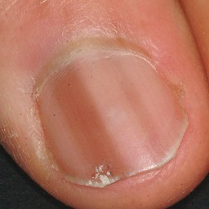 warrants second opinion#579 **Confidences:**normal = 88%; non-serious = 8%; warrants second opinion = 4%;   
The nail's condition is normal with confidence score of 88%.  
Otherwise it is non-serious with confidence score of 8%.×

 warrants second opinion#319 **Confidences:**normal = 0%; non-serious = 96%; warrants second opinion = 4%;   
The nail's condition is non-serious with confidence score of 96%.  
The confidence score for it warranting a second opinion is 4%.×

 warrants second opinion#269 **Confidences:**normal = 0%; non-serious = 96%; warrants second opinion = 4%;   
The nail's condition is non-serious with confidence score of 96%.  
The confidence score for it warranting a second opinion is 4%.×

 warrants second opinion#124 **Confidences:**normal = 95%; non-serious = 0%; warrants second opinion = 5%;   
The nail's condition is normal with confidence score of 95%.  
The confidence score for it warranting a second opinion is 5%.×

 warrants second opinion#54 **Confidences:**normal = 95%; non-serious = 0%; warrants second opinion = 5%;   
The nail's condition is normal with confidence score of 95%.  
The confidence score for it warranting a second opinion is 5%.×

 warrants second opinion#49 **Confidences:**normal = 91%; non-serious = 0%; warrants second opinion = 9%;   
The nail's condition is normal with confidence score of 91%.  
The confidence score for it warranting a second opinion is 9%.×

 warrants second opinion#114 **Confidences:**normal = 1%; non-serious = 91%; warrants second opinion = 9%;   
The nail's condition is non-serious with confidence score of 91%.  
The confidence score for it warranting a second opinion is 9%.×

 warrants second opinion#74 **Confidences:**normal = 36%; non-serious = 54%; warrants second opinion = 10%;   
Not very sure whether the nail is OK or not. Sorry.×

 warrants second opinion#39 **Confidences:**normal = 69%; non-serious = 20%; warrants second opinion = 11%;   
The nail's condition is normal with confidence score of 69%.  
Otherwise it is non-serious with confidence score of 20%.×

 warrants second opinion#199 **Confidences:**normal = 82%; non-serious = 3%; warrants second opinion = 15%;   
The nail's condition is normal with confidence score of 82%.  
The confidence score for it warranting a second opinion is 15%.×

 warrants second opinion#229 **Confidences:**normal = 81%; non-serious = 0%; warrants second opinion = 19%;   
The nail's condition is normal with confidence score of 81%.  
The confidence score for it warranting a second opinion is 19%.×

 warrants second opinion#224 **Confidences:**normal = 80%; non-serious = 0%; warrants second opinion = 20%;   
It might be warrant a second opinion (confidence score is 20%) ×

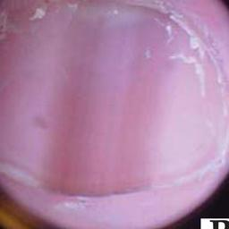 warrants second opinion#574 **Confidences:**normal = 76%; non-serious = 2%; warrants second opinion = 22%;   
It might be warrant a second opinion (confidence score is 22%) ×

 warrants second opinion#384 **Confidences:**normal = 74%; non-serious = 1%; warrants second opinion = 25%;   
It might be warrant a second opinion (confidence score is 25%) ×

 warrants second opinion#19 **Confidences:**normal = 71%; non-serious = 4%; warrants second opinion = 25%;   
It might be warrant a second opinion (confidence score is 25%) ×

 warrants second opinion#139 **Confidences:**normal = 8%; non-serious = 60%; warrants second opinion = 32%;   
It might be warrant a second opinion (confidence score is 32%) ×

 warrants second opinion#364 **Confidences:**normal = 13%; non-serious = 47%; warrants second opinion = 40%;   
Not very sure whether the nail is OK or not. Sorry.×

 warrants second opinion#324 **Confidences:**normal = 41%; non-serious = 18%; warrants second opinion = 41%;   
Not very sure whether the nail is OK or not. Sorry.×

 warrants second opinion#119 **Confidences:**normal = 56%; non-serious = 0%; warrants second opinion = 43%;   
Not very sure whether the nail is OK or not. Sorry.×

 warrants second opinion#344 **Confidences:**normal = 0%; non-serious = 56%; warrants second opinion = 44%;   
Not very sure whether the nail is OK or not. Sorry.×

 warrants second opinion#264 **Confidences:**normal = 0%; non-serious = 51%; warrants second opinion = 49%;   
Not very sure whether the nail is OK or not. Sorry.×

 warrants second opinion#354 **Confidences:**normal = 0%; non-serious = 51%; warrants second opinion = 49%;   
Not very sure whether the nail is OK or not. Sorry.×

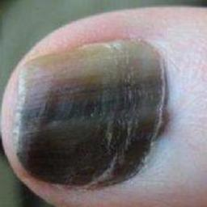 warrants second opinion#659 **Confidences:**normal = 49%; non-serious = 0%; warrants second opinion = 51%;   
Not very sure whether the nail is OK or not. Sorry.×

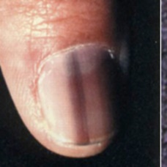 warrants second opinion#684 **Confidences:**normal = 5%; non-serious = 40%; warrants second opinion = 54%;   
Not very sure whether the nail is OK or not. Sorry.×

 warrants second opinion#284 **Confidences:**normal = 0%; non-serious = 45%; warrants second opinion = 54%;   
Not very sure whether the nail is OK or not. Sorry.×

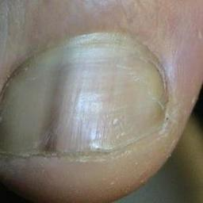 warrants second opinion#644 **Confidences:**normal = 33%; non-serious = 7%; warrants second opinion = 59%;   
Not very sure whether the nail is OK or not. Sorry.×

 warrants second opinion#374 **Confidences:**normal = 1%; non-serious = 35%; warrants second opinion = 64%;   
It is most likely that the nail indicates something that warrants a second opinion and you should seek medical advice. (Confidence score is 64%)×

 warrants second opinion#79 **Confidences:**normal = 32%; non-serious = 0%; warrants second opinion = 68%;   
It is most likely that the nail indicates something that warrants a second opinion and you should seek medical advice. (Confidence score is 68%)×

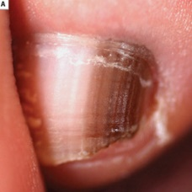 warrants second opinion#614 **Confidences:**normal = 0%; non-serious = 31%; warrants second opinion = 69%;   
It is most likely that the nail indicates something that warrants a second opinion and you should seek medical advice. (Confidence score is 69%)×

 warrants second opinion#9 **Confidences:**normal = 2%; non-serious = 28%; warrants second opinion = 70%;   
It is most likely that the nail indicates something that warrants a second opinion and you should seek medical advice. (Confidence score is 70%)×

 warrants second opinion#89 **Confidences:**normal = 29%; non-serious = 1%; warrants second opinion = 70%;   
It is most likely that the nail indicates something that warrants a second opinion and you should seek medical advice. (Confidence score is 70%)×

 warrants second opinion#34 **Confidences:**normal = 28%; non-serious = 0%; warrants second opinion = 71%;   
It is most likely that the nail indicates something that warrants a second opinion and you should seek medical advice. (Confidence score is 71%)×

 warrants second opinion#84 **Confidences:**normal = 5%; non-serious = 21%; warrants second opinion = 73%;   
It is most likely that the nail indicates something that warrants a second opinion and you should seek medical advice. (Confidence score is 73%)×

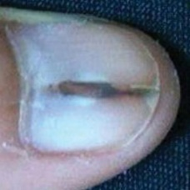 warrants second opinion#649 **Confidences:**normal = 24%; non-serious = 1%; warrants second opinion = 76%;   
It is most likely that the nail indicates something that warrants a second opinion and you should seek medical advice. (Confidence score is 76%)×

 warrants second opinion#174 **Confidences:**normal = 0%; non-serious = 23%; warrants second opinion = 76%;   
It is most likely that the nail indicates something that warrants a second opinion and you should seek medical advice. (Confidence score is 76%)×

 warrants second opinion#204 **Confidences:**normal = 1%; non-serious = 22%; warrants second opinion = 78%;   
It is most likely that the nail indicates something that warrants a second opinion and you should seek medical advice. (Confidence score is 78%)×

 warrants second opinion#439 **Confidences:**normal = 18%; non-serious = 4%; warrants second opinion = 78%;   
It is most likely that the nail indicates something that warrants a second opinion and you should seek medical advice. (Confidence score is 78%)×

 warrants second opinion#399 **Confidences:**normal = 18%; non-serious = 4%; warrants second opinion = 78%;   
It is most likely that the nail indicates something that warrants a second opinion and you should seek medical advice. (Confidence score is 78%)×

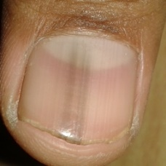 warrants second opinion#654 **Confidences:**normal = 20%; non-serious = 1%; warrants second opinion = 79%;   
It is most likely that the nail indicates something that warrants a second opinion and you should seek medical advice. (Confidence score is 79%)×

 warrants second opinion#169 **Confidences:**normal = 11%; non-serious = 10%; warrants second opinion = 80%;   
It is most likely that the nail indicates something that warrants a second opinion and you should seek medical advice. (Confidence score is 80%)×

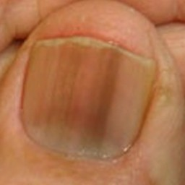 warrants second opinion#549 **Confidences:**normal = 20%; non-serious = 0%; warrants second opinion = 80%;   
It is most likely that the nail indicates something that warrants a second opinion and you should seek medical advice. (Confidence score is 80%)×

 warrants second opinion#569 **Confidences:**normal = 20%; non-serious = 0%; warrants second opinion = 80%;   
It is most likely that the nail indicates something that warrants a second opinion and you should seek medical advice. (Confidence score is 80%)×

 warrants second opinion#484 **Confidences:**normal = 0%; non-serious = 20%; warrants second opinion = 80%;   
It is most likely that the nail indicates something that warrants a second opinion and you should seek medical advice. (Confidence score is 80%)×

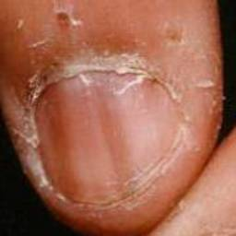 warrants second opinion#544 **Confidences:**normal = 1%; non-serious = 18%; warrants second opinion = 81%;   
It is most likely that the nail indicates something that warrants a second opinion and you should seek medical advice. (Confidence score is 81%)×

 warrants second opinion#464 **Confidences:**normal = 0%; non-serious = 17%; warrants second opinion = 83%;   
It is most likely that the nail indicates something that warrants a second opinion and you should seek medical advice. (Confidence score is 83%)×

 warrants second opinion#489 **Confidences:**normal = 0%; non-serious = 17%; warrants second opinion = 83%;   
It is most likely that the nail indicates something that warrants a second opinion and you should seek medical advice. (Confidence score is 83%)×

 warrants second opinion#209 **Confidences:**normal = 1%; non-serious = 15%; warrants second opinion = 84%;   
It is most likely that the nail indicates something that warrants a second opinion and you should seek medical advice. (Confidence score is 84%)×

 warrants second opinion#259 **Confidences:**normal = 8%; non-serious = 8%; warrants second opinion = 84%;   
It is most likely that the nail indicates something that warrants a second opinion and you should seek medical advice. (Confidence score is 84%)×

 warrants second opinion#69 **Confidences:**normal = 12%; non-serious = 3%; warrants second opinion = 85%;   
It is most likely that the nail indicates something that warrants a second opinion and you should seek medical advice. (Confidence score is 85%)×

 warrants second opinion#419 **Confidences:**normal = 2%; non-serious = 11%; warrants second opinion = 87%;   
It is most likely that the nail indicates something that warrants a second opinion and you should seek medical advice. (Confidence score is 87%)×

 warrants second opinion#304 **Confidences:**normal = 0%; non-serious = 13%; warrants second opinion = 87%;   
It is most likely that the nail indicates something that warrants a second opinion and you should seek medical advice. (Confidence score is 87%)×

 warrants second opinion#339 **Confidences:**normal = 1%; non-serious = 11%; warrants second opinion = 88%;   
It is most likely that the nail indicates something that warrants a second opinion and you should seek medical advice. (Confidence score is 88%)×

 warrants second opinion#334 **Confidences:**normal = 1%; non-serious = 10%; warrants second opinion = 88%;   
It is most likely that the nail indicates something that warrants a second opinion and you should seek medical advice. (Confidence score is 88%)×

 warrants second opinion#429 **Confidences:**normal = 0%; non-serious = 11%; warrants second opinion = 88%;   
It is most likely that the nail indicates something that warrants a second opinion and you should seek medical advice. (Confidence score is 88%)×

 warrants second opinion#444 **Confidences:**normal = 0%; non-serious = 10%; warrants second opinion = 90%;   
It is most likely that the nail indicates something that warrants a second opinion and you should seek medical advice. (Confidence score is 90%)×

 warrants second opinion#314 **Confidences:**normal = 8%; non-serious = 3%; warrants second opinion = 90%;   
It is most likely that the nail indicates something that warrants a second opinion and you should seek medical advice. (Confidence score is 90%)×

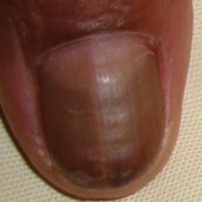 warrants second opinion#634 **Confidences:**normal = 8%; non-serious = 1%; warrants second opinion = 91%;   
It is most likely that the nail indicates something that warrants a second opinion and you should seek medical advice. (Confidence score is 91%)×

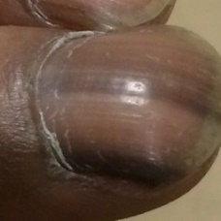 warrants second opinion#564 **Confidences:**normal = 8%; non-serious = 1%; warrants second opinion = 91%;   
It is most likely that the nail indicates something that warrants a second opinion and you should seek medical advice. (Confidence score is 91%)×

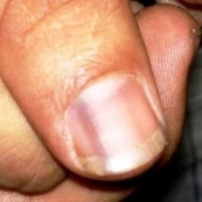 warrants second opinion#584 **Confidences:**normal = 8%; non-serious = 0%; warrants second opinion = 91%;   
It is most likely that the nail indicates something that warrants a second opinion and you should seek medical advice. (Confidence score is 91%)×

 warrants second opinion#109 **Confidences:**normal = 5%; non-serious = 4%; warrants second opinion = 92%;   
It is most likely that the nail indicates something that warrants a second opinion and you should seek medical advice. (Confidence score is 92%)×

 warrants second opinion#244 **Confidences:**normal = 5%; non-serious = 3%; warrants second opinion = 92%;   
It is most likely that the nail indicates something that warrants a second opinion and you should seek medical advice. (Confidence score is 92%)×

 warrants second opinion#389 **Confidences:**normal = 7%; non-serious = 1%; warrants second opinion = 93%;   
It is most likely that the nail indicates something that warrants a second opinion and you should seek medical advice. (Confidence score is 93%)×

 warrants second opinion#104 **Confidences:**normal = 7%; non-serious = 0%; warrants second opinion = 93%;   
It is most likely that the nail indicates something that warrants a second opinion and you should seek medical advice. (Confidence score is 93%)×

 warrants second opinion#514 **Confidences:**normal = 0%; non-serious = 7%; warrants second opinion = 93%;   
It is most likely that the nail indicates something that warrants a second opinion and you should seek medical advice. (Confidence score is 93%)×

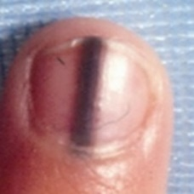 warrants second opinion#559 **Confidences:**normal = 6%; non-serious = 1%; warrants second opinion = 93%;   
It is most likely that the nail indicates something that warrants a second opinion and you should seek medical advice. (Confidence score is 93%)×

 warrants second opinion#239 **Confidences:**normal = 6%; non-serious = 0%; warrants second opinion = 94%;   
It is most likely that the nail indicates something that warrants a second opinion and you should seek medical advice. (Confidence score is 94%)×

 warrants second opinion#434 **Confidences:**normal = 2%; non-serious = 4%; warrants second opinion = 94%;   
It is most likely that the nail indicates something that warrants a second opinion and you should seek medical advice. (Confidence score is 94%)×

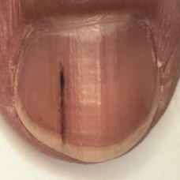 warrants second opinion#604 **Confidences:**normal = 5%; non-serious = 1%; warrants second opinion = 94%;   
It is most likely that the nail indicates something that warrants a second opinion and you should seek medical advice. (Confidence score is 94%)×

 warrants second opinion#134 **Confidences:**normal = 5%; non-serious = 0%; warrants second opinion = 95%;   
It is most likely that the nail indicates something that warrants a second opinion and you should seek medical advice. (Confidence score is 95%)×

 warrants second opinion#474 **Confidences:**normal = 0%; non-serious = 5%; warrants second opinion = 95%;   
It is most likely that the nail indicates something that warrants a second opinion and you should seek medical advice. (Confidence score is 95%)×

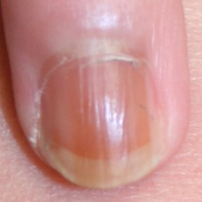 warrants second opinion#619 **Confidences:**normal = 5%; non-serious = 0%; warrants second opinion = 95%;   
It is most likely that the nail indicates something that warrants a second opinion and you should seek medical advice. (Confidence score is 95%)×

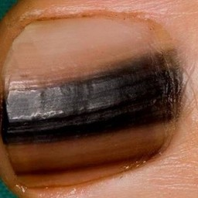 warrants second opinion#639 **Confidences:**normal = 3%; non-serious = 2%; warrants second opinion = 95%;   
It is most likely that the nail indicates something that warrants a second opinion and you should seek medical advice. (Confidence score is 95%)×

 warrants second opinion#494 **Confidences:**normal = 4%; non-serious = 1%; warrants second opinion = 95%;   
It is most likely that the nail indicates something that warrants a second opinion and you should seek medical advice. (Confidence score is 95%)×

 warrants second opinion#184 **Confidences:**normal = 4%; non-serious = 0%; warrants second opinion = 96%;   
It is most likely that the nail indicates something that warrants a second opinion and you should seek medical advice. (Confidence score is 96%)×

 warrants second opinion#164 **Confidences:**normal = 4%; non-serious = 0%; warrants second opinion = 96%;   
It is most likely that the nail indicates something that warrants a second opinion and you should seek medical advice. (Confidence score is 96%)×

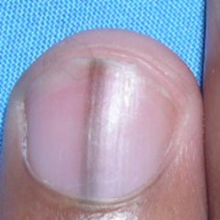 warrants second opinion#534 **Confidences:**normal = 4%; non-serious = 0%; warrants second opinion = 96%;   
It is most likely that the nail indicates something that warrants a second opinion and you should seek medical advice. (Confidence score is 96%)×

 warrants second opinion#294 **Confidences:**normal = 0%; non-serious = 4%; warrants second opinion = 96%;   
It is most likely that the nail indicates something that warrants a second opinion and you should seek medical advice. (Confidence score is 96%)×

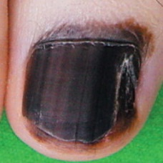 warrants second opinion#669 **Confidences:**normal = 2%; non-serious = 2%; warrants second opinion = 96%;   
It is most likely that the nail indicates something that warrants a second opinion and you should seek medical advice. (Confidence score is 96%)×

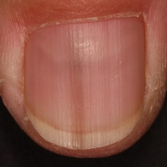 warrants second opinion#594 **Confidences:**normal = 4%; non-serious = 0%; warrants second opinion = 96%;   
It is most likely that the nail indicates something that warrants a second opinion and you should seek medical advice. (Confidence score is 96%)×

 warrants second opinion#509 **Confidences:**normal = 0%; non-serious = 4%; warrants second opinion = 96%;   
It is most likely that the nail indicates something that warrants a second opinion and you should seek medical advice. (Confidence score is 96%)×

 warrants second opinion#469 **Confidences:**normal = 2%; non-serious = 1%; warrants second opinion = 97%;   
It is most likely that the nail indicates something that warrants a second opinion and you should seek medical advice. (Confidence score is 97%)×

 warrants second opinion#189 **Confidences:**normal = 3%; non-serious = 0%; warrants second opinion = 97%;   
It is most likely that the nail indicates something that warrants a second opinion and you should seek medical advice. (Confidence score is 97%)×

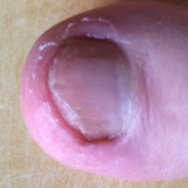 warrants second opinion#674 **Confidences:**normal = 3%; non-serious = 0%; warrants second opinion = 97%;   
It is most likely that the nail indicates something that warrants a second opinion and you should seek medical advice. (Confidence score is 97%)×

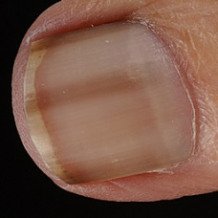 warrants second opinion#524 **Confidences:**normal = 3%; non-serious = 0%; warrants second opinion = 97%;   
It is most likely that the nail indicates something that warrants a second opinion and you should seek medical advice. (Confidence score is 97%)×

 warrants second opinion#179 **Confidences:**normal = 0%; non-serious = 3%; warrants second opinion = 97%;   
It is most likely that the nail indicates something that warrants a second opinion and you should seek medical advice. (Confidence score is 97%)×

 warrants second opinion#214 **Confidences:**normal = 2%; non-serious = 0%; warrants second opinion = 97%;   
It is most likely that the nail indicates something that warrants a second opinion and you should seek medical advice. (Confidence score is 97%)×

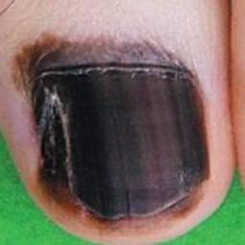 warrants second opinion#629 **Confidences:**normal = 3%; non-serious = 0%; warrants second opinion = 97%;   
It is most likely that the nail indicates something that warrants a second opinion and you should seek medical advice. (Confidence score is 97%)×

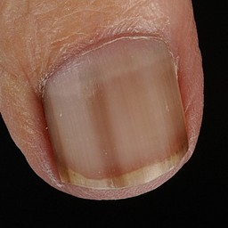 warrants second opinion#529 **Confidences:**normal = 3%; non-serious = 0%; warrants second opinion = 97%;   
It is most likely that the nail indicates something that warrants a second opinion and you should seek medical advice. (Confidence score is 97%)×

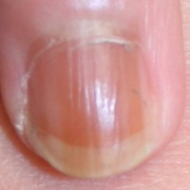 warrants second opinion#589 **Confidences:**normal = 2%; non-serious = 0%; warrants second opinion = 97%;   
It is most likely that the nail indicates something that warrants a second opinion and you should seek medical advice. (Confidence score is 97%)×

 warrants second opinion#454 **Confidences:**normal = 0%; non-serious = 2%; warrants second opinion = 98%;   
It is most likely that the nail indicates something that warrants a second opinion and you should seek medical advice. (Confidence score is 98%)×

 warrants second opinion#499 **Confidences:**normal = 2%; non-serious = 1%; warrants second opinion = 98%;   
It is most likely that the nail indicates something that warrants a second opinion and you should seek medical advice. (Confidence score is 98%)×

 warrants second opinion#159 **Confidences:**normal = 0%; non-serious = 2%; warrants second opinion = 98%;   
It is most likely that the nail indicates something that warrants a second opinion and you should seek medical advice. (Confidence score is 98%)×

 warrants second opinion#99 **Confidences:**normal = 1%; non-serious = 1%; warrants second opinion = 98%;   
It is most likely that the nail indicates something that warrants a second opinion and you should seek medical advice. (Confidence score is 98%)×

 warrants second opinion#394 **Confidences:**normal = 2%; non-serious = 0%; warrants second opinion = 98%;   
It is most likely that the nail indicates something that warrants a second opinion and you should seek medical advice. (Confidence score is 98%)×

 warrants second opinion#404 **Confidences:**normal = 2%; non-serious = 0%; warrants second opinion = 98%;   
It is most likely that the nail indicates something that warrants a second opinion and you should seek medical advice. (Confidence score is 98%)×

 warrants second opinion#154 **Confidences:**normal = 1%; non-serious = 0%; warrants second opinion = 98%;   
It is most likely that the nail indicates something that warrants a second opinion and you should seek medical advice. (Confidence score is 98%)×

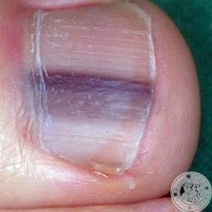 warrants second opinion#664 **Confidences:**normal = 0%; non-serious = 1%; warrants second opinion = 98%;   
It is most likely that the nail indicates something that warrants a second opinion and you should seek medical advice. (Confidence score is 98%)×

 warrants second opinion#254 **Confidences:**normal = 1%; non-serious = 0%; warrants second opinion = 99%;   
It is most likely that the nail indicates something that warrants a second opinion and you should seek medical advice. (Confidence score is 99%)×

 warrants second opinion#64 **Confidences:**normal = 0%; non-serious = 1%; warrants second opinion = 99%;   
It is most likely that the nail indicates something that warrants a second opinion and you should seek medical advice. (Confidence score is 99%)×

 warrants second opinion#424 **Confidences:**normal = 0%; non-serious = 1%; warrants second opinion = 99%;   
It is most likely that the nail indicates something that warrants a second opinion and you should seek medical advice. (Confidence score is 99%)×

 warrants second opinion#504 **Confidences:**normal = 1%; non-serious = 0%; warrants second opinion = 99%;   
It is most likely that the nail indicates something that warrants a second opinion and you should seek medical advice. (Confidence score is 99%)×

 warrants second opinion#409 **Confidences:**normal = 1%; non-serious = 0%; warrants second opinion = 99%;   
It is most likely that the nail indicates something that warrants a second opinion and you should seek medical advice. (Confidence score is 99%)×

 warrants second opinion#379 **Confidences:**normal = 1%; non-serious = 0%; warrants second opinion = 99%;   
It is most likely that the nail indicates something that warrants a second opinion and you should seek medical advice. (Confidence score is 99%)×

 warrants second opinion#279 **Confidences:**normal = 1%; non-serious = 0%; warrants second opinion = 99%;   
It is most likely that the nail indicates something that warrants a second opinion and you should seek medical advice. (Confidence score is 99%)×

 warrants second opinion#349 **Confidences:**normal = 0%; non-serious = 1%; warrants second opinion = 99%;   
It is most likely that the nail indicates something that warrants a second opinion and you should seek medical advice. (Confidence score is 99%)×

 warrants second opinion#144 **Confidences:**normal = 1%; non-serious = 0%; warrants second opinion = 99%;   
It is most likely that the nail indicates something that warrants a second opinion and you should seek medical advice. (Confidence score is 99%)×

 warrants second opinion#219 **Confidences:**normal = 1%; non-serious = 0%; warrants second opinion = 99%;   
It is most likely that the nail indicates something that warrants a second opinion and you should seek medical advice. (Confidence score is 99%)×

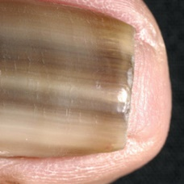 warrants second opinion#554 **Confidences:**normal = 0%; non-serious = 1%; warrants second opinion = 99%;   
It is most likely that the nail indicates something that warrants a second opinion and you should seek medical advice. (Confidence score is 99%)×

 warrants second opinion#29 **Confidences:**normal = 0%; non-serious = 0%; warrants second opinion = 99%;   
It is most likely that the nail indicates something that warrants a second opinion and you should seek medical advice. (Confidence score is 99%)×

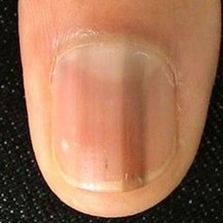 warrants second opinion#539 **Confidences:**normal = 0%; non-serious = 0%; warrants second opinion = 99%;   
It is most likely that the nail indicates something that warrants a second opinion and you should seek medical advice. (Confidence score is 99%)×

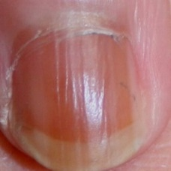 warrants second opinion#609 **Confidences:**normal = 0%; non-serious = 0%; warrants second opinion = 100%;   
It is most likely that the nail indicates something that warrants a second opinion and you should seek medical advice. (Confidence score is 100%)×

 warrants second opinion#369 **Confidences:**normal = 0%; non-serious = 0%; warrants second opinion = 100%;   
It is most likely that the nail indicates something that warrants a second opinion and you should seek medical advice. (Confidence score is 100%)×

 warrants second opinion#194 **Confidences:**normal = 0%; non-serious = 0%; warrants second opinion = 100%;   
It is most likely that the nail indicates something that warrants a second opinion and you should seek medical advice. (Confidence score is 100%)×

 warrants second opinion#309 **Confidences:**normal = 0%; non-serious = 0%; warrants second opinion = 100%;   
It is most likely that the nail indicates something that warrants a second opinion and you should seek medical advice. (Confidence score is 100%)×

 warrants second opinion#519 **Confidences:**normal = 0%; non-serious = 0%; warrants second opinion = 100%;   
It is most likely that the nail indicates something that warrants a second opinion and you should seek medical advice. (Confidence score is 100%)×

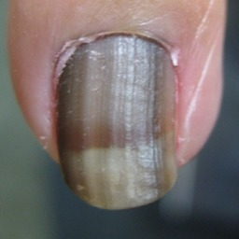 warrants second opinion#599 **Confidences:**normal = 0%; non-serious = 0%; warrants second opinion = 100%;   
It is most likely that the nail indicates something that warrants a second opinion and you should seek medical advice. (Confidence score is 100%)×

 warrants second opinion#299 **Confidences:**normal = 0%; non-serious = 0%; warrants second opinion = 100%;   
It is most likely that the nail indicates something that warrants a second opinion and you should seek medical advice. (Confidence score is 100%)×

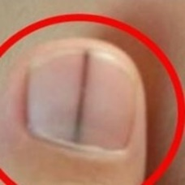 warrants second opinion#679 **Confidences:**normal = 0%; non-serious = 0%; warrants second opinion = 100%;   
It is most likely that the nail indicates something that warrants a second opinion and you should seek medical advice. (Confidence score is 100%)×

 warrants second opinion#129 **Confidences:**normal = 0%; non-serious = 0%; warrants second opinion = 100%;   
It is most likely that the nail indicates something that warrants a second opinion and you should seek medical advice. (Confidence score is 100%)×

 warrants second opinion#249 **Confidences:**normal = 0%; non-serious = 0%; warrants second opinion = 100%;   
It is most likely that the nail indicates something that warrants a second opinion and you should seek medical advice. (Confidence score is 100%)×

 warrants second opinion#149 **Confidences:**normal = 0%; non-serious = 0%; warrants second opinion = 100%;   
It is most likely that the nail indicates something that warrants a second opinion and you should seek medical advice. (Confidence score is 100%)×

 warrants second opinion#289 **Confidences:**normal = 0%; non-serious = 0%; warrants second opinion = 100%;   
It is most likely that the nail indicates something that warrants a second opinion and you should seek medical advice. (Confidence score is 100%)×

 warrants second opinion#274 **Confidences:**normal = 0%; non-serious = 0%; warrants second opinion = 100%;   
It is most likely that the nail indicates something that warrants a second opinion and you should seek medical advice. (Confidence score is 100%)×

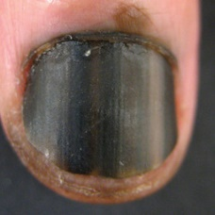 warrants second opinion#624 **Confidences:**normal = 0%; non-serious = 0%; warrants second opinion = 100%;   
It is most likely that the nail indicates something that warrants a second opinion and you should seek medical advice. (Confidence score is 100%)×

 warrants second opinion#329 **Confidences:**normal = 0%; non-serious = 0%; warrants second opinion = 100%;   
It is most likely that the nail indicates something that warrants a second opinion and you should seek medical advice. (Confidence score is 100%)×

 warrants second opinion#234 **Confidences:**normal = 0%; non-serious = 0%; warrants second opinion = 100%;   
It is most likely that the nail indicates something that warrants a second opinion and you should seek medical advice. (Confidence score is 100%)×